Name
Date

DNA Fingerprints Prove Crime Does Not Pay
A Gel Electrophoresis Simulation

Objectives
- Perform a paper simulation of gel electrophoresis
- Determine the criminal in an imaginary scenario by comparing DNA profiles of the suspects with a DNA profile from the crime scene

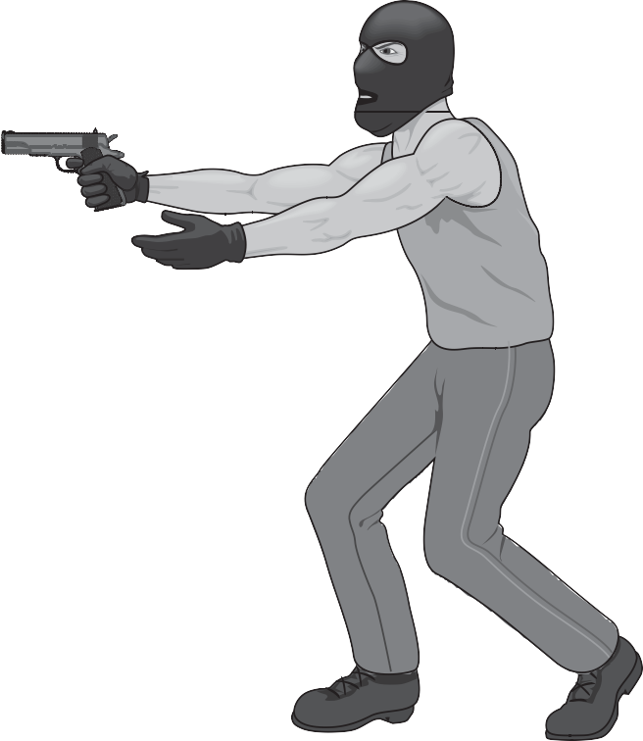Materials
- Scissors
- Glue or tape
- Pencil
- Clear metric ruler

Background
Today more than ever, scientists and police inves- tigators are working hand-in-hand to solve crimes. Police investigators carefully survey a crime scene for evidence that the criminal may have left behind. Fo- rensic scientists are those who are concerned with relationships between science and law. They ana- lyze the evidence found at the crime scene. DNA profiling (DNA fingerprinting) is one of the latest tools used to identify criminals. Only a small amount of a sample that contains DNA is needed to make a DNA profile.
How does the process of DNA profiling work? DNA taken from body cells can be cut into small fragments by restriction enzymes. These fragments are called restric- tion fragment length polymorphs (RFLPs), pronounced ‘’riflips." Everyone’s DNA is different and separates into fragments of different lengths and compositions. The

number and sizes of DNA fragments produced depend on the specific sequence of nucleotides in a DNA sample.
After the DNA is cut, the resulting fragments are separated by gel electrophore- sis. A gel is a flat, rectangular slab of a thin, jellylike material. DNA fragments are placed in wells at one end of a gel. The gel is poured into a gel chamber that has a positive electrode at one end and a negative electrode at the other end. The gel is arranged so that the wells are located near the negatively charged electrode. DNA has a negative charge, so the fragments move through the gel toward the positive pole. The small fragments move faster and farther through the gel than the large fragments.
After the gel is stained, the DNA fragments appear as separate and distinct bands. The larger fragments are near the negative pole, and the smaller fragments are near the positive pole. Everyone’s DNA produces a distinct banding pattern when cut with two or more restriction enzymes. If the banding pattern produced by a criminal suspect matches the pattern from DNA left at the crime scene, police in- vestigators have most likely found their criminal.

Procedure
  - Read the following scenario:
Fairfield Community College has been rocked by an outbreak of robberies. In the last month, 10 female coeds were victims of a purse snatcher. Until now, the only clue police had was the following description of the assailant from the victims:
White male Over 6 feet tall Muscular build
Wears blues jeans, sleeveless shirt, and a black ski hood

Last night, another woman was attacked in the dimly lit college parking lot. Before the assailant escaped, the victim grabbed his ski hood, snagging a couple of locks of hair in the process.
Today, police gathered six suspects that match the sketchy description of the purse snatcher. Unfortunately, none of the victims could positively identify any of the suspects in a lineup.
Police investigators plan to run a DNA profile on cells from the roots of hair found in the ski hood. They also intend to extract some roots from each of the suspects so the crime lab can compare the DNA of the suspects to the DNA of the criminal.
  - The three pages following these directions contain the evidence and test you will need for solving the crime. On the first page, you will find complete, un- cut DNA strands from each of the six suspects as well as a DNA strand from

the crime scene. The dotted lines drawn through the strands of DNA repre- sent the places where restriction enzymes will cut them. Using scissors, care- fully cut each suspect’s DNA strand into RFLPs by cutting on the dotted lines. Do not mix up the RFLPs of the suspects.
  - Tape the second and third pages together to form a complete model of a gel. If your model is taped correctly, the column Sample Sizes will be at the far left. The columns called Wells to Deposit DNA represent holes in the gel that are located near the negative electrode. (During the actual gel electro- phoresis process, RFLPs of each suspect are placed in the wells, where they will begin to travel through the gel.)
  - The column called Sample Sizes contains various-sized pieces of DNA. Their positions demonstrate how far through the gel a RFLP of that size can move toward the positive electrode at the bottom of the gel chamber. Very large pieces cannot move very far. Small pieces can migrate all the way to the pos- itive electrode.
  - Match the RFLPs of Suspect #1 to those in the Sample Sizes column. Tape the RFLPs in the appropriate boxes under the column Suspect #1. Align your RFLPs on the left and in the lower half of the appropriate box (see Figure 1). You may have more than one RFLP for a box. If so, tape the additional RFLPs above the first—not side by side (see Figure 2). Repeat this process on each suspect’s DNA and on that taken from the crime scene.

Figure 1 Figure 2

  - Compare the DNA of each suspect with the DNA of the crime scene. Answer the Postlab Questions.

Models of DNA Samples
Dotted lines represent locations where restriction enzymes will cut these pieces of DNA.

DNA Samples

Crime scene

Suspect 1

Suspect 2

Suspect 3

Suspect 4

Suspect 5

Suspect 6

ELECTROPHORESIS

NEGATIVE ELECTRODE

Sample Sizes | Well to Deposit DNA | Well to Deposit DNA | Well to Deposit DNA
 | Suspect #1 | Suspect #2 | Suspect #3
10
9
8
7
6
5
4
3
2
1

POSITIVE ELECTRODE

CHAMBER

NEGATIVE ELECTRODE

Well to Deposit DNA | Well to Deposit DNA | Well to Deposit DNA | Well to Deposit DNA
Suspect #4 | Suspect #5 | Suspect #6 | Crime Scene

POSITIVE ELECTRODE

Biology in Our Lives • Activity/Lab 5–5: DNA Fingerprints Prove Crime Does Not Pay Page 6

Postlab Questions
- This activity models gel electrophoresis. Describe what each of the following pa- per simulation steps represents:
  - The scissors that cut the DNA strands

  - The small pieces of paper you taped on the model gel.

- Did the small RFLPs that you cut from the model DNA strands appear near the bottom or top of the gel chamber? Explain.

- What is the function of the wells in the gel model?

- Looking at your completed chart, do you think the criminal was one of the six suspects? If so, which suspect did you select? Why?

- Do you think this process could be used to determine the father of a child in a paternity suit? If so, explain your reasoning.

