Name: __________________________________________ Distillation and Electrolysis

Background Information: Intermolecular forces are attractions between molecules and are responsible for many physical properties including the melting point and boiling point of a substance. It is relatively easy to change the strength of intermolecular forces via physical changes. Intermolecular forces are weakened or strengthened during phase changes. Intramolecular forces, also known as chemical bonds, hold atoms together in a compound and generally require more energy to overcome. In this activity, we will use identification techniques to determine gases evolved in various changes. From that evidence, we will determine if the changes that occurred were due to intermolecular or intramolecular forces.

Part 1: Identification of common gases evolved in lab investigations.
Read the following information about testing procedures used to identify an unknown gas. Then answer the questions that follow.
Several gases can easily be generated in the laboratory. These include carbon dioxide, hydrogen, oxygen, chlorine, ammonia, and water vapor. To test for the presence of carbon dioxide, a burning wood splint brought near the gas will be extinguished. To test for the presence of Hydrogen gas, a burning wood splint will make a “pop” noise. Oxygen gas near a burning wood splint, that has recently been extinguished, will re-light. The presence of ammonia or chlorine is usually noticed by a sharp odor. Ammonia can also be tested with red litmus paper, which will turn blue in the presence of ammonia. The chlorine gas can be tested with blue litmus paper that will turn red or starch-iodine paper, which will turn a dark blue or black color. Water vapor will extinguish a flame much like carbon dioxide, and it will also turn cobalt chloride paper from blue to pink.
- Which gases can be tested using a burning wood splint? How will you differentiate between the gases?

- Which gases can be tested using test papers? How will you differentiate between the gases?

Part 2: Distillation of Soda

Materials: large and small beaker, graduated cylinder, stopper, colored soda (such as root beer, no sprite), aluminum foil, crushed ice, beaker tongs, cobalt chloride paper, and hot plate.

Pre-Activity Questions:
- Is soda a pure substance or a mixture? Provide evidence in your answer.

- Make a prediction about what will happen as the soda boils over the hot plate in a closed container. Draw a model of your prediction in the box below.

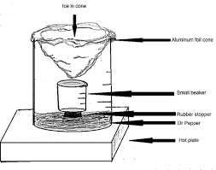
Procedure:
- Measure 50.0mL of soda in a graduated cylinder. Pour into the large beaker.
- Mass the small dry beaker.
- Place a rubber stopper in the large beaker to create a platform for the smaller beaker. Place the smaller beaker on the rubber stopper. Ensure the small beaker is still dry.
- Make a “cold finger” by creating a cone of aluminum with no holes. Place it so the tip of the cone is hanging just above the small beaker, the top of the cone is covering the rim of the large beaker. Cover the large beaker with the aluminum to prevent vapors from escaping the large beaker as it boils.
- Place crushed ice in the cone to fill the cone.
- Place the entire set up on the hot plate and allow the soda to boil until the ice melts on the cold finger. Do not add more ice. Make observations about the color, volume, and phase changes occurring in the set up.
- Once the ice has melted, remove the set up from the hot plate using beaker tongs.
- IMMEDIATELY Test the vapors from the boiling liquid with cobalt chloride paper.
- Test the vapors with a burning wood splint.
- When, cooled, measure the mass of liquid collected in the smaller beaker
- Pour the new liquid into a cylinder to measure the volume.

Data and Observations:

Post Activity Questions:
- Calculate the mass of the new liquid collected

- Calculate the density of the new liquid.

- Identify a vapor formed when the soda was distilled. Provide evidence to support your claim.

- What is the identity of the liquid in the small beaker? Provide evidence to support your claim.

- Amend your prediction in the pre-activity question: what occurred as the soda was distilled? Re-draw your model.

Part 3: Electrolysis of Water

Materials: clear plastic cup, two metal thumb tacks, 9 volt battery, distilled water, baking soda, plastic pipettes, scissors, wood splints, and lighter.

Pre-Activity Question: Predict what will happen as electricity is conducted through water. Draw a model to help explain your prediction.

Procedure:
- Place two metal thumb tacks through the bottom of a small plastic cup so the points of the tacks are pointing up into the cup. The thumb tacks should be spaced the same as the tall terminals on the 9V battery.
- Pour water into the plastic cup to fill approximately ¾ of the way.
- Add baking soda to the water and stir.
- Cut two plastic pipettes near the tip, to allow the tip to have a wider opening.
- Fill the pipettes with the baking soda water
- Invert the full pipettes into the water one over each thumbtack. Do not allow any air bubbles into the pipettes. One student should hold the pipettes in the cup.
- Place the cup over the 9V battery so the terminals touch the tacks. Record observations as the changes occur.
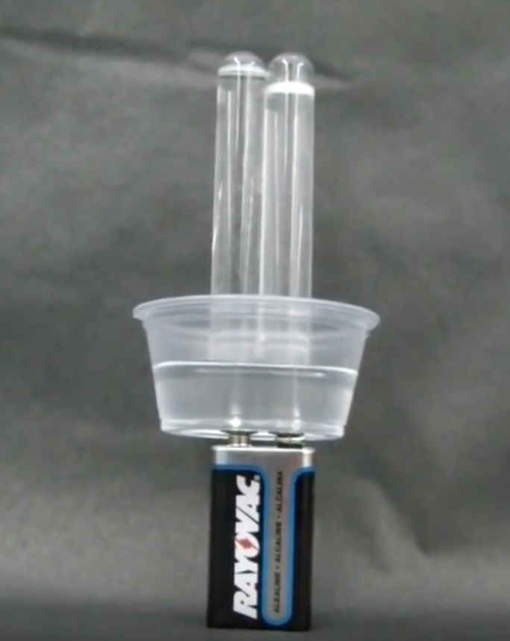
- Once a significant amount of gas has formed in the pipettes, cut the tip of one pipette and test the gas formed with a burning wood splint. Do this quickly (but carefully!) so that the gas formed doesn’t disperse into the air. Record observations.
- Repeat the previous step with the other pipette and record observations.

Observations:

Post Activity Questions:
- What is the identity of the gas(es) formed in the electrolysis? Provide evidence to support your claim.

- Based on the chemical formula of water, why did more hydrogen gas form than oxygen gas?

- Amend your prediction in the pre-activity question: what occurred as electricity was conducted through the water? Re-draw your model.

- Explain the major differences between distillation and electrolysis:

 | Distillation | Electrolysis
Physical or chemical change?
Evidence of previous answer:
Changes the intramolecular or intermolecular forces?
Reasoning for previous answer:

