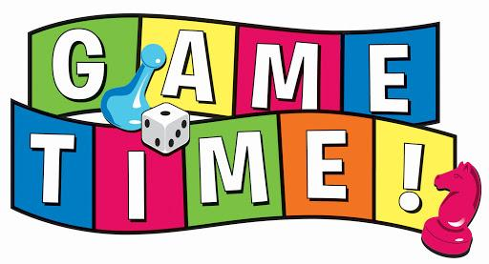
Create a Game Project

Game Requirements: Create a chemistry game idea that future AP chemistry students could play to refine their chemistry skills and content knowledge. The game should be creative and could either mock an existing game or be a completely new idea! You don’t actually have to create the entire game, just come up with the gaming concepts in order to pitch it to your peers. Your peers will choose to “fund” certain games for production. The game with the most funding will accrue bonus points. You may choose to work alone or with one partner. Requirements include:
- A list of game rules and materials (like the insert for a board game).
- An explanation about how to win the game (could be in the game rules above).
- At least 20 game chemistry questions with answers at an AP level.
- A creative approach that engages game players.
Consider looking at your own board games at home or online that have rules and model those inserts.

Game Rubric
 | 0 | 5 | 10 | 15 | 20
Creativity/Fun Factor | No theme. Models an existing game. The game is not engaging or motivating. | Theme is vague. Mostly models and existing games. The game has limited engagement or motivating value. | Theme is vague. Includes rules added to traditional games or a new gaming concept. The game is somewhat engaging or motivating. | Interesting theme. Includes a few rules added to traditional games or a semi new gaming concept. The game is mostly engaging and motivates the player to continue playing. | Interesting theme. Includes rules added to traditional games or a new gaming concept. The game is engaging and motivates the player to continue playing.
Game Rules/Materials | Rules are confusing and pieces are not well described. | Some rules are outlined and necessary game pieces are somewhat explained. | Some rules are outlined and necessary game pieces are mostly explained. | Most rules are outlined and all necessary game pieces are explained. | All rules are outlined clearly and all necessary game pieces are explained.
Game Examples | Less than 5 chemistry questions are provided. Answer key is incomplete. | At least 5 chemistry questions are provided. Answer key is somewhat accurate and complete. | At least 10 chemistry questions are provided. Answer key is somewhat accurate and complete. | At least 15 chemistry questions are provided. Answer key is mostly accurate and complete. | At least 20 chemistry questions are provided. Answer key is accurate and complete.
Difficulty | Questions and rules of play are below or well above an AP level. | Questions and rules of play are not at an appropriate AP level. | Questions and rules of play are somewhat at an appropriate AP level. | Questions and rules of play are mostly at an appropriate AP level. | Questions and rules of play are at an appropriate AP level.
How to Win | Winning the game requires learning the chemistry content. | Winning the game requires learning the chemistry content. | Winning the game requires learning the chemistry content. | Winning the game requires learning the chemistry content. | Winning the game requires learning the chemistry content.

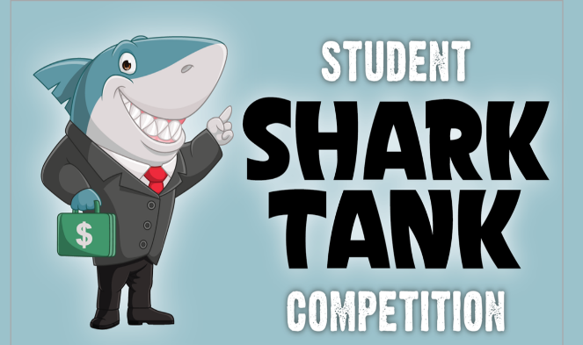
Sales Pitch Requirements: You (and your partner) will pitch your game idea to your peers for funding (like on Shark Tank). You will have up to 5 minutes to explain the major concepts of the game. After all presentations are completed, peers will “fund” their chosen games and evaluate your presentation. You will submit the game project along with your presentation. Your presentation should include:
- A video presentation or “commercial”
- An example of game play
- Engaging presentation

Sales Pitch Rubric
 | 0 | 5 | 10 | 15 | 20
Timing | Presentation needed to be cut off or extremely short | Presentation ran much too long or extremely short | Presentation ran too long or too short | Presentation ran a little long or short | Presentation is completed in about 5 minutes
Presentation | Voices were unclear, inaudible, and not confident. | Voices were unclear, inaudible, or not confident. | Voices were somewhat clear, audible, and confident. | Voices were mostly clear, audible, and confident. | Voices were clear, audible, and confident.
Comprehension | Presentation did not explain the game's purpose, rules, and how to win. | Presentation lacked explanation of game purpose, rules, and how to win. | Presentation somewhat explained the game purpose, rules, and how to win. | Presentation mostly explained game purpose, rules, and how to win. | Presentation explained the game's purpose, rules, and how to win.
Examples | Examples of how to play and chemistry questions were not demonstrated. | Examples of how to play and chemistry questions were barely demonstrated. | Examples of how to play and chemistry questions were somewhat demonstrated. | Only one example of how to play and chemistry questions was clearly demonstrated. | Examples of how to play and chemistry questions were clearly demonstrated.
Entertainment Value | Presentation lacked entertainment. | Presentation was engaging at some parts. | Presentation was somewhat engaging and entertaining. | Presentation was mostly engaging and entertaining. | Presentation was engaging and entertaining.

