Confirmatory Tests
- You have tested a sample of white powder with the Scott test reagent and obtained a blue color. You think you have __________________________________, but you ask the spectroscopy lab for a confirmation. They provide the following spectrum below: What is your sample?
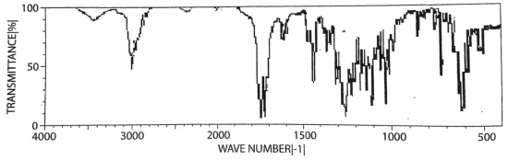
- Upon arresting a suspect, police find a white powdered residue in their pocket. They suspect methamphetamines and the presumptive color test with the _______________________________________ reagent turned an orange brown color. The suspect claims it is Adderall (amphetamine) which he takes for ADHD. You ask the spectroscopy lab for a confirmation. They provide the following spectrum below: Is the suspect carrying illegal drugs?
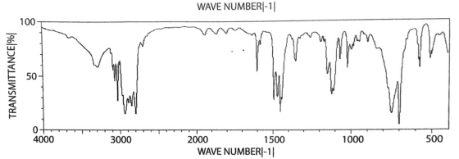
- You get a violet-blue color with the Marquis reagent on a sample submitted to your lab. You as the mass spectroscopy lab to check it for you, and they submit the following mass spectra below (there are two components): What is in your sample?
