Name: _________________________________ Chromatography

Background Information: In this experiment, you're using a technique called chromatography. The name comes from the Greek words chroma and graph for "color writing." The technique was developed in 1910 by Russian botanist Mikhail Tsvet. He used it for separating the pigments that made up plant dyes. Paper chromatography is also a way to analyze mixtures, such as ink, by separating them into the original chemicals that are included in their makeup. Crime scene investigators use chromatography to identify and separate many different substances. Detectives often use chromatography to identify drugs from narcotics to aspirin in blood and urine. A solvent dissolves the substance and separates it based on its polarity. Different solutes will travel at different rates. Each solute will have a specific retention factor, Rf value.
Rf = distance from origin to center of spot / distance from origin to solvent front

Guiding Question: Johnny brings home his test grade and his parents take a look. The grade looks odd, and 80 that looks like it possibly could have been a 30 converted to an 80, with something crossed out on top. Did Johnny cheat? Use Rf values to confirm.

Materials: Pencils, filter paper, toothpicks, food colors, various suspect pens, forged check, 400mL beakers.
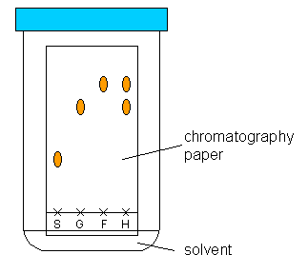
Pre-Lab Questions:
- Why do we have to write in pencil (not pen) when we label the paper?

- What is the solvent and what is the solute in this lab?

- Measure the Rf value of mark “S” assuming the solvent moved up the entire paper.

- Compare the Rf values of marks “G,” “F,” and “H” to explain the composition of mark “H.”

- Circle the word(s) that best describe your understanding of mixtures. Then write a scientific explanation to defend the claim you chose.
Prediction: The black color in markers is a (mixture / pure color).

Reasoning:

Part 1 Procedure: Learning Chromatography Techniques
- Place a small amount of water in your beaker, just enough to fill the bottom of the beaker.
- Hold the chromatography paper on the outside of the beaker. Mark the water line on the filter paper.
- Label which marker will be used on that paper and where the marker will start.
- Place a small dot from the markers on the paper in their labeled places. Make sure your dots are above the water line otherwise the color will bleed into the water.
- Place the paper in the beaker of water. If the colors are under the water line, restart. Otherwise, allow the water to creep up the paper until it is ¾ of the way up. All papers should have the same amount of water on them.
Part 1 Data
Marker | Streak or spot? | Colors bottom to top | Rf Values

Part 1 Questions:
- Construct a claim that supports or contradicts the prediction made in the pre-lab questions: Is black marker a pure color or a mixture?

- Provide evidence that supports your claim. Use your reasoning skills to explain why your evidence is relevant.

- Paper chromatography separates mixtures by their polarities. Water is polar and it dissolves polar things. Knowing this, which colors from the markers were the most polar? The least polar?

Part 2 Guiding Question: Did Johnny cheat? Use R_{f} values to confirm your answer.
Data and Observations:

- Construct a claim that answers the guiding question: Did Johnny cheat?

- Provide evidence and reasoning that supports your claim.

- Justify the results of your experiment using scientific laws and theories.

