Name: ________________________________________________ What do Chemists do?

Background: Part of the fun of chemistry is being able to identify different substances by tests. To identify substances, chemists use reagents, which are known chemicals or mixtures of chemicals. When a reagent is added to a sample being tested, it may or it may not produce an observable change. Both the positive and the negative result will help identify the unknown sample being tested.

In this simple system of common household chemicals, four powders and three liquid reagents are used:

POWDERS: | LIQUID REAGENTS:
A: Baking Soda  B: Corn Starch  C: Alka-Seltzer  D: Table Salt | I: White Vinegar  II: Iodine Tincture  III: Distilled Water

Materials: mortar and pestle, spot plates, NaCl, Sodium bicarbonate, corn starch, Alka-Seltzer, test tubes, vinegar, iodine, H₂O, transfer pipette

Objectives:
- To identify several common household chemicals by their chemical properties.
- To analyze mixtures of common household chemicals of unknown composition.

Safety: Goggles and aprons must be worn at all times.

Procedure:

PART 1: IDENTIFICATION Record the composition of the four powders and of the three liquid reagents by reading the contents on the commercial package. List properties such as color and texture.

Baking soda: ______________________________ White Vinegar: ___________________________________
Corn Starch: ______________________________ Iodine Tincture: _________________________________
Alka-Seltzer: ______________________________ Distilled water: __________________________________
Table Salt: ________________________________

PART 2: TESTING REAGENTS
- Break an Alka-Seltzer tablet into two halves. Grind one half of the tablet into a powder using a mortar and pestle.
- Place small amounts (use your spatula) of the four powders in each of the 12 depressions of your spot plate as shown in the diagram below.

Baking Soda | Corn  Starch | Alka  Seltzer | Table  Salt
Baking  Soda | Corn  Starch | Alka  Seltzer | Table  Salt
Baking Soda | Corn  Starch | Alka  Seltzer | Table  Salt

- To each of the 12 solid samples add a few drops of the three liquid reagents, in the manner indicated in the diagram below:

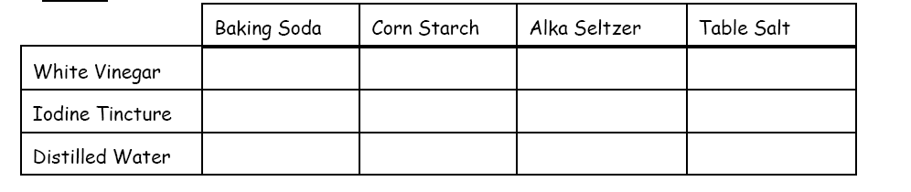

PART 3: Application
- Obtain small amounts of “unknown samples” 1, 2, and 3.
- Place unknown 1 down the first three spots.
- Place unknown 2 down the next three spots.
- Place unknown 3 down the third three spots.
- React the unknown solids with the white vinegar, iodine tincture, and water like in Part 2.
- Record your observations.

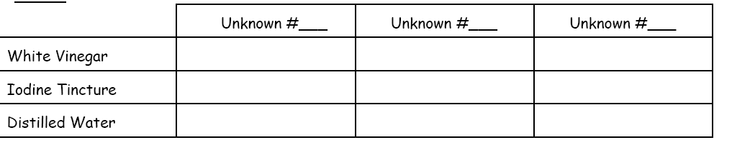

Conclusions: The unknown samples are either salt, baking soda, Alka-Seltzer, or corn starch.

- Unknown 1 must be _________________________ because we observed ______________________________________
_________________________________________________________________________________________________________________
- Unknown 2 must be _________________________ because we observed ______________________________________
_________________________________________________________________________________________________________________
- Unknown 3 must be _________________________ because we observed ______________________________________
_________________________________________________________________________________________________________________

