Directions for adding the class calendar to your Gmail Account:

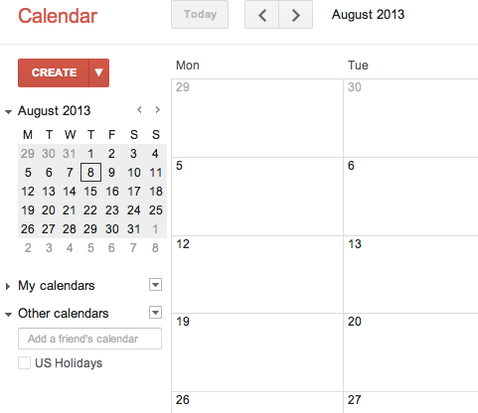
1. Log into your gmail account and click on calendar. On the bottom left hand side of your screen click “other calendars”.

2. Click “Add by URL”
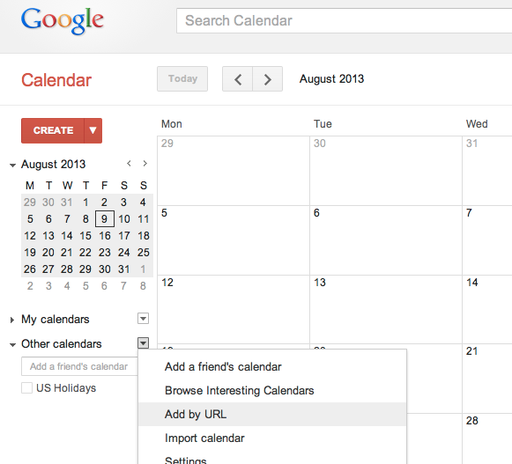

3. Copy and paste the following link:

AP Chemistry: https://calendar.google.com/calendar/ical/r17vfdoc18ipiqr0socmito3os%40group.calendar.google.com/public/basic.ics

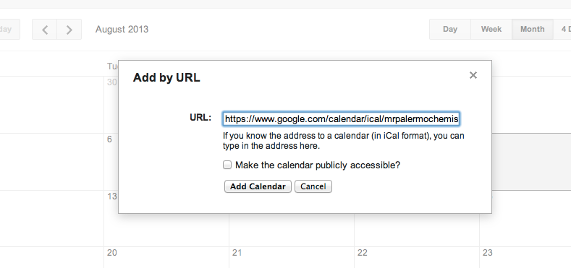

Honors chemistry:
https://calendar.google.com/calendar/ical/ n717ajshhj979ldr8d4pq7q1v8%40group.calendar.google.com/public/basic.ics

4. Click “Add Calendar”.

