Vocabulary
For each word, provide a short but specific definition from YOUR OWN BRAIN! No boring textbook definitions. Write something to help you remember the word. Explain the word as if you were explaining it to an elementary school student. Give an example if you can. Don’t use the words given in your definition!
Ionic Bond: ________________________________________________________________________________
Covalent Bond: _____________________________________________________________________________
Metallic Bond: ______________________________________________________________________________
Molecular: _________________________________________________________________________________
Sea of electrons: ____________________________________________________________________________
Electronegativity: ___________________________________________________________________________
Polar Bond: ________________________________________________________________________________
Nonpolar Bond: _____________________________________________________________________________
Polar Molecule: _____________________________________________________________________________
Nonpolar Molecule: _________________________________________________________________________
Linear Molecule: ____________________________________________________________________________
Bent Molecule: _____________________________________________________________________________
Pyramidal Molecule: _________________________________________________________________________
Tetrahedral Molecule: _______________________________________________________________________
Shared pairs: _______________________________________________________________________________
Unshared pairs: _____________________________________________________________________________
Symmetrical: _______________________________________________________________________________
Intermolecular Forces: _______________________________________________________________________
Hydrogen Bonding: __________________________________________________________________________
Video 5.1 Types of Bonds
- Compounds can be differentiated by their chemical and physical properties.
- Two major categories of compounds are _______________ and molecular (covalent) compounds.
- Chemical bonds are formed when valence electrons are _________________ from one atom to another (ionic), __________________ between atoms (covalent), mobile within a metal (metallic).
- When a bond is broken, energy is ______________. When a bond is formed, energy is _____________.
- Atoms attain a stable valence electron configuration by bonding with other atoms. ___________________________ have stable valence configurations and tend not to bond.
- Physical properties of substances can be explained in terms of chemical bonds and intermolecular forces. These properties include conductivity, malleability, solubility, hardness, melting point, and boiling point
- When an atom gains one or more electrons, it becomes a negative ion and its radius __________________. When an atom loses one or more electrons, it becomes a positive ion and its radius _____________________.
- Metals tend to react with nonmetals to form ___________________ compounds. Nonmetals tend to react with other nonmetals to form molecular (____________________) compounds. Ionic compounds contain polyatomic ions have both ionic and covalent bonding.

- Fill in notes on the chart below:
 | Ionic | Covalent | Metallic
Hard or soft?
Shiny or dull?
High or low
melting point?
High or low
boiling point?
Conducts?
(When?)
Solid, liquid or gas?
What happens to
the electrons?
Example of a substance with these bonds
- What type of bonds do the following pairs make?

  - C+O __________________ d. P+Cl __________________

  - N+H __________________ e. Mg+F __________________

  - Na+S __________________ f. Au __________________

- What is a “sea of electrons?” How is it formed?

- Why is the “sea of electrons” important in metallic bonding? (What can the electrons do?)

Video 5.2 Ionic Bonds

Show your work to find the formula and draw the Lewis dot structures (#1-4 from the video):
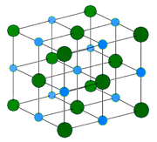
- K+Br
- Mg+Cl
- Na+S
- Ca+S
- K+O
- Mg+N
- Al+Br
- How many electrons do all the cations have when they bond?
- How many electrons do the anions have when they bond?
- What is happening to the electrons? (shared, transferred or sea?)

Video 5.3 Covalent Bonds

- In a multiple covalent bond, more than one pair of electrons are ____________ between two atoms.
- Electron-dot diagrams (Lewis structures) can represent the valence electron arrangement in elements, compounds, and ions.

- What does VSEPR stand for/ what does it mean?

- What are the four major shapes? Draw each shape out labeled with the name:

- Show the drawings:
- PCl₃
- SiCl₂H₂
- Br₂
- H₂S

Video 5.4 Bond Polarity
- _________________________ indicates how strongly an atom of an element attracts electrons in a chemical bond. Electronegativity values are assigned according to arbitrary scales.
- The electronegativity difference between two bonded atoms is used to assess the degree of __________________________ in a bond.

- What makes the bond between H and O polar?

- The most polar bonds are those between atoms that have the biggest difference in electronegativity. Which is the most polar? Show your work.

  - HF b. HCl c. HBr d. HI
- Which of the choices in number two was nonpolar? What was its difference in electronegativity?

- Complete the table from the video:

Electronegativity difference | Bond type
 | Nonpolar
 | Polar
 | Very Polar
 | Ionic

- Label as containing polar or nonpolar bonds:
  - NO b. CCl₄ c. F₂ d. CH₄ e. CS₂ f. H₂O

Video 5.5 Molecular Polarity
- Molecular polarity can be determined by the shape of the molecule and the______________ of charge. __________________ (nonpolar) molecules include CO₂, CH₄, and diatomic elements. Asymmetrical (polar) molecules include HCl, NH₃, and H₂O.

Use polar or nonpolar in the blanks and your answers:

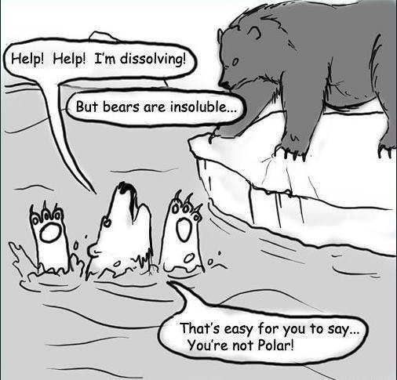
- Symmetrical molecules are ________________ and asymmetrical molecules are ________________.
- Water is ________________ and dissolves other ________________ substances.
- Draw the following and decide if they are polar or nonpolar molecules:
SiF₄
H₂S
HI
H₂

______________ _______________ _______________ _______________
- Hexene does not dissolve in water so it is ________________ and dissolves other ________________ substances.
- Why do we need to use both water AND soap when we wash our hands?
- Polar molecules are more organized. When they are near a magnetic plate they align to the plate. Show how HF would align to the plate:

- - - - - - - - - - - - -

+ + + + + + + + + + + + +
Video 5.6 Intermolecular Forces of Attraction

Define the words to complete the following chart using prior knowledge and today’s video:
Compound:

London Dispersal:

Strength:

Example:
Ionic Bonds:

Properties:

Example:
Dipole-Dipole:

Strength:

Example:
London Dispersal:

Strength:

Example:
Ion-Dipole:

Strength:

Example:

Covalent Bonds:

Properties:

Example:
Metallic Bonds:

Properties:

Example:
Intermolecular Forces:
Intramolecular Forces:

- Which has the strongest bonds holding atoms together?
  - CH₄ b. NO₂ c.LiCl d. PCl₃
- Which has the strongest forces holding molecules together?
  - H₂O b. SO₂ c. CF₄ d. H₂
- Why does water form droplets with high surface tension (what kind of forces does it have)?

- Breaking bonds is ________________. Breaking forces is ________________. That is why breaking bonds requires so much energy and changes the substance; meanwhile breaking forces only changes the phase. (Use physical or chemical in the blanks.)
Review
- What occurs as two atoms of fluorine combine to become a molecule of fluorine?
  - A bond is formed as energy is absorbed.
  - A bond is formed as energy is released.
C) A bond is broken as energy is absorbed.
D) A bond is broken as energy is released.

- To break a chemical bond, energy must be
  - Absorbed C) destroyed
  - produced D) released

- Which quantities must be conserved in all chemical reactions?
  - mass, charge, density
  - mass, charge, energy
C) charge, volume, density
D) charge, volume, energy

- Given the balanced equation representing a reaction:
H2(g) + Cl2(g) 2HCl(g) + energy
Which statement describes the energy changes in this
reaction?
  - Energy is absorbed as bonds are formed only
  - Energy is released as bonds are broken, only.
  - Energy is absorbed as bonds are broken, and energy is released as bonds are formed.
  - Energy is absorbed as bonds are formed, and energy is released as bonds are broken.

- Given the formula for hydrazine:
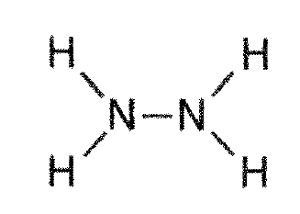
How many pairs of electrons are shared between the
two nitrogen atoms?
A) 1 B) 2 C) 3 D) 4

- Which symbol represents an atom in the ground state with the most stable valence electron configuration?
  - B B) O C) Li D) Ne

- Given the Lewis electron-dot diagram:
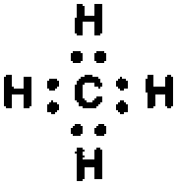
Which electrons are represented by all of the dots?
  - the carbon valence electrons, only
  - the hydrogen valence electrons, only
C) the carbon and hydrogen valence electrons
D) all of the carbon and hydrogen electrons

- Which is the correct electron-dot formula for a molecule of chlorine?
A) 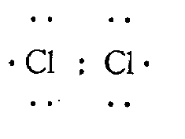 B) 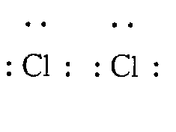
C) 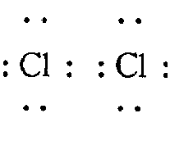 D) 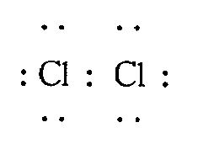

- Which electron-dot diagram represents H2?
A) 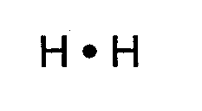 B) 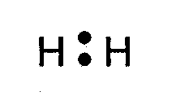
C) 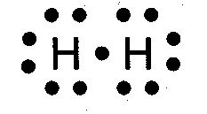 D) 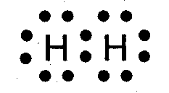

- Which formulas represent one ionic compound and one molecular compound?
  - N2 and SO2 C) Cl2 and H2S
  - BaCl2 and N2O4 D) NaOH and BaSO4

- Element X reacts with chlorine to form an ionic compound that has the formula XCl2. To which group on the Periodic Table could element X belong?
  - Group 1 C) Group 2
  - Group 13 D) Group 15

- Which element forms an ionic compound when it reacts with lithium?
  - K B) Fe C) Kr D) Br

- The bonds in BaO are best described as
  - covalent, because valence electrons are shared
  - covalent, because valence electrons are transferred
  - ionic, because valence electrons are shared
  - ionic, because valence electrons are transferred

- What occurs when an atom loses an electron?
  - The atom's radius decreases and the atom becomes a negative
  - The atom's radius decreases and the atom becomes a positive
  - The atom's radius increases and the atom becomes a negative
  - The atom's radius increases and the atom becomes a positive

- As a chlorine atom becomes a negative ion, the atom
  - gains an electron and its radius increases
  - gains an electron and its radius decreases
  - loses an electron and its radius increases
  - loses an electron and its radius decreases

- Which compound contains both ionic and covalent bonds?
  - CaCO3 B) PCl3 C) MgF2 D) CH2O

- Which sample contains particles in a rigid, fixed, geometric pattern?
  - CO2(aq) B) HCl(g) C) H2O() D) KCl(s)

- Which statement best describes the substance that results when electrons are transferred from a metal to a nonmetal?
  - It contains ionic bonds and has a low melting point.
  - It contains ionic bonds and has a high melting point.
  - It contains covalent bonds and has a low melting point.
  - It contains covalent bonds and has a high melting point.
- When a reaction occurs between atoms with ground-state electron configurations of 2-1 and 2-7, the bond formed is mainly
  - polar covalent C) nonpolar covalent
  - metallic D) ionic

- Which type of substance can conduct electricity in the liquid phase but not in the solid phase?
  - ionic compound
  - molecular compound
  - metallic element
  - nonmetallic element

- Based on bond type, which compound has the highest melting point?
  - CH3OH B) C6H14 C) CaCl2 D) CCl4

- The data table below represents the properties determined by the analysis of substances A, B, C, and D.
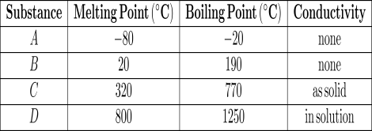
Which substance is an ionic compound?
  - A B) B C) C D) D

- A hard substance that has a high melting point and is a poor conductor of electricity in the solid phase could be
  - CO2 B) Mg C) NaCl D) CCl4

- As NaC₂H₃O_{2(s)} is stirred into water and dissolves, the electrical conductivity of the solution
  - Decreases C)increases
  - remains the same

- Which compound has the strongest hydrogen bonding between its molecules?
  - HBr B) HCl C) HF D) HI

- What is the total number of electrons shared in a double covalent bond?
A) 1 B) 2 C) 3 D) 4
- Which type of bond is found between atoms of solid cobalt?
  - nonpolar covalent C) polar covalent
  - metallic D) ionic

- The nitrogen atoms in a molecule of N2 share a total of
  - one pair of electrons
  - one pair of protons
  - three pairs of electrons
  - three pairs of protons

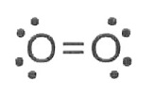
- Given a formula for oxygen:

What is the total number of electrons shared
between the atoms represented in this
formula?
A) 1 B) 2 C) 8 D) 4

- Given the formula of a substance:
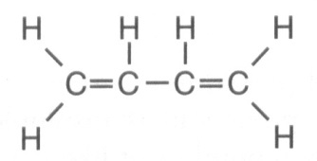
What is the total number of shared electrons in a
molecule of this substance?
A) 22 B) 11 C) 9 D) 6

- Which two substances are covalent compounds?
  - C6 H12 O6 (s) and KI(s)
  - C6 H12 O6 (s) and HCl(g)
  - KI(s) and NaCl(s)
  - NaCl(s) and HCl(g)

- A chemist performs the same tests on two homogeneous white crystalline solids, A and B. The results are shown in the table below.
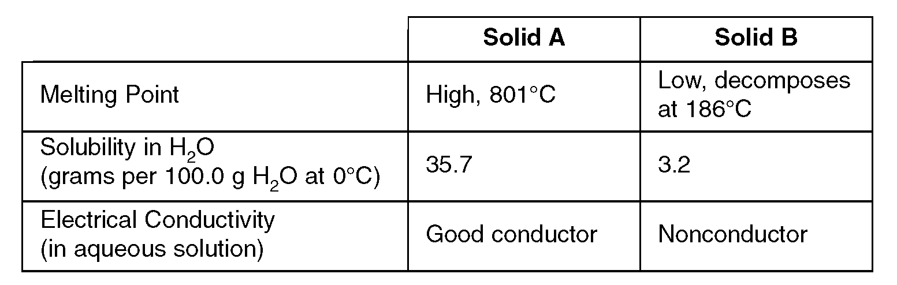
The results of these tests suggest that
  - both solids contain only ionic bonds
  - both solids contain only covalent bonds
  - solid A contains only covalent bonds and solid B contains only ionic bonds
  - solid A contains only ionic bonds and solid B contains only covalent bonds

- Which terms describe a substance that has a low melting point and poor electrical conductivity?
  - covalent and metallic
  - covalent and molecular
  - ionic and molecular
  - ionic and metallic

- A solid substance is an excellent conductor of electricity. The chemical bonds in this substance are most likely
  - ionic, because the valence electrons are shared between atoms
  - ionic, because the valence electrons are mobile
  - metallic, because the valence electrons are stationary
  - metallic, because the valence electrons are mobile

- Metallic bonding occurs between metal atoms that have
  - filled energy levels and low ionization energies
  - filled energy levels and high ionization energies
  - unfilled energy levels and low ionization energies
  - unfilled energy levels and high ionization energies

- Which substance contains particles held together by metallic bonds?
  - Ni(s) B) Ne(s) C) N2(s) D) I2(s)

- Based on electronegativity values, which type of elements tends to have the greatest attraction for electrons in a bond?
  - metals C) metalloids
  - nonmetals D) noble gases

- Which bond is least polar?
  - As–Cl B) Bi–Cl C) P–Cl D) N–Cl

- If the electronegativity difference between the elements in compound NaX is 2.1, what is element X?
  - Br B) Cl C) F D) O

- Which type of molecule is CF4?
  - polar, with a symmetrical distribution of charge
  - polar, with an asymmetrical distribution of charge
  - nonpolar, with a symmetrical distribution of charge
  - nonpolar, with an asymmetrical distribution of charge

- Which compound has molecules that form the strongest hydrogen bonds?
  - HI B) HBr C) HF D) HCl

- Which electron-dot diagram represents a molecule that has a polar covalent bond?
A) B) 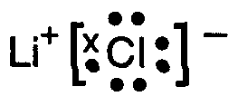
C) D) 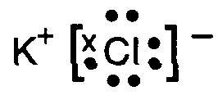

- Which formula represents a polar molecule?
  - H2 B) H2O C) CO2 D) CCl4

- The liquids hexane and water are placed in a test tube. The test tube is stoppered, shaken, and placed in a test tube rack. The liquids separate into two distinct layers because hexane and water have different
  - formula masses B) molecular polarities
  - C) pH values D) specific heats

- Hexane (C6H14) and water do not form a solution. Which statement explains this phenomenon?
  - Hexane is polar and water is nonpolar.
  - Hexane is ionic and water is polar.
  - Hexane is nonpolar and water is polar.
  - Hexane is nonpolar and water is ionic.

- The symmetrical structure of the CH4 molecule is due to the fact that the four single bonds between carbon and hydrogen atoms are directed toward the corners of a
  - Triangle C) tetrahedron
  - square D) rectangle

- Which diagram best represents a polar molecule?
A) 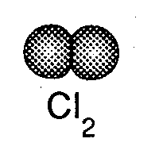 B) 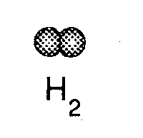
C) 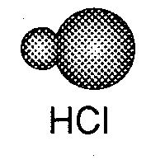 D) 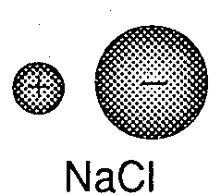

- The table below contains data for compounds A, B, C, and D
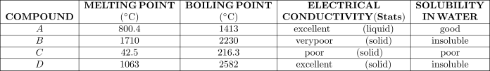
Which list identifies the type of bonding characteristic of each compound's solid phase?
  - A -ionic B -network C -metallic D-molecular
  - A -network B -ionic C -molecular D-metallic
  - A -metallic B -molecular C-network D-ionic
  - A -ionic B -network C -molecular D-metallic
- Hydrogen bonding is a type of
  - strong covalent bond
  - weak ionic bond
  - strong intermolecular force
  - weak intermolecular force

- Which statement explains why H2O has a higher boiling point than N2?
  - H2O has greater molar mass than N2.
  - H2O has less molar mass than N2.
  - H2O has stronger intermolecular forces then N2.
  - H2O has weaker intermolecular forces than N2.

- The table below shows four compounds and the boiling point of each.
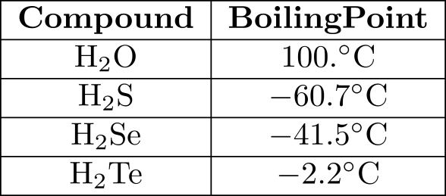
Which type of molecular attraction accounts for the high boiling point of H2O?
  - molecule-ion C) ion-ion
  - hydrogen bonding D) van der Waals

- The table below shows the normal boiling point of four compounds.
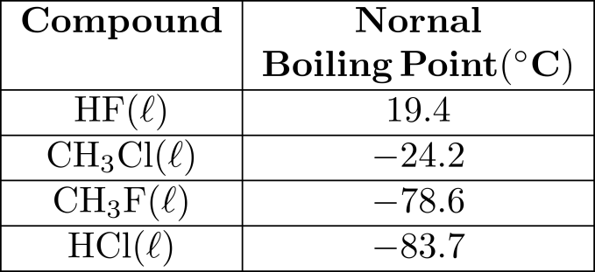
Which compound has the strongest intermolecular forces?
  - HF() C) CH3Cl()
  - CH3F() D) HCl()

- Which characteristic of the compound C5H12 causes it to have a higher normal boiling point than C2H6?
  - The distance between molecules of C5H12 is greater.
  - The force of attraction between molecules of C5H12 is greater.
  - C5H12 has a larger number of ionic bonds.
  - C5H12 has a larger number of double bonds.

