Name: _______________________________________ Bonding and IMF Lab
Guiding Question: How do bonds and intermolecular forces affect properties of compounds?
Materials: Petri dish, water, food dye, mineral oil, toothpicks ~ Petri dish, water, pepper, detergent ~ balloon ~ capillary tubes, water, acetone ~ pennies, droppers, mineral oil, water ~ petri dish, acetone, Styrofoam pieces ~ NH₄Cl, NaOH, 2 beakers, water, balance.
Pre-Lab Questions: Fill in the blanks with: bonds or forces, endothermic or exothermic, and polar or nonpolar.
- Breaking ______________ requires chemical changes to occur.
- Breaking ______________ requires physical changes to occur.
- Phase changes involve the breaking or forming of ________________.
- Breaking bonds and forces will be characterized as ___________________ reactions.
- Forming bonds and forces will be characterized as ___________________ reactions.
- Like dissolves like. This means that ______________ solvents dissolve polar solutes. Additionally, nonpolar solvents dissolve _____________ solutes.
- Circle the word(s) in the claim that best complete the prediction. Then, write a scientific explanation to defend your choice.
Prediction: Physical changes are a result of changes in (bonds/forces).
Reasoning: _________________________________________________________________________
____________________________________________________________________________________
Procedure/Data: You must write down observations/data from each lab station and complete that station’s questions. Clean up each lab station before going to the next station.
- In a petri dish, pour enough water to fill the left half of the dish. Fill the other side with mineral oil. Place one drop of food dye to the oil side. Then move that small bubble over to the water side.
Observations:

- In terms of polarity, why doesn’t the water and oil mix well?

- In terms of polarity, why does the food dye dissolve in one solvent and not the other?

- In a petri dish, add water until it is half full. Sprinkle pepper on the top of the water. Notice and write down if the pepper is sinking or floating. Add a few drops of liquid detergent.
Observations:

- Surface tension of liquids results when forces of attraction in a liquid are high enough to resist external forces. In terms of forces and surface tension, explain why water can hold up the pepper, although pepper is denser than water.

- In terms of forces and surface tension, explain what happened when the detergent was added.

- Run the water in the faucet on a very low setting. Rub a balloon on someone in your group’s clothing (preferably something soft). Bring the balloon near the stream of water without getting the balloon wet.
Observations:

- In terms of charges, what happened when you were rubbing the balloon on your clothes?

- In terms of polarity and charges, why was the water attracted to the balloon?

- Hold a capillary tube upright (with one open end to the ceiling) and place it in the water. Place the tube end on a piece of paper towel. Then repeat with a new tube but using acetone.
Observations:

- Capillary action occurs when substances with strong forces travel up a tube with a small diameter due to adhesive forces. In terms of forces, explain why water travelled up the tube but not the acetone.

- In terms of concentration (amount of a substance), explain why the water was drawn out of the tube by the paper towel and then spread out in a circle on the paper.

- Using a dropper, count and record how many drop of water fit on the head of a penny without spilling over. Repeat using mineral oil instead of water.
Observations:

- Surface tension of liquids results when forces of attraction in a liquid are high enough to resist external forces. In terms of forces and surface tension, explain why more drops of one liquid stayed on the head of the penny than the other liquid.

- A penny could hold more drops of soapy water than oil. But the penny would hold less drops of soapy water than pure water. Explain why soapy water places second in this experiment in terms of forces.
- In a petri dish, add acetone until about 1/3 of the dish is full. Then place in a piece of Styrofoam.
Observations:

- In terms of polarity, explain your observations.
- In terms of polarity, why doesn’t Styrofoam dissolve in water?

- Fill both beakers with approximately 25mL of water. In beaker 1 add approximately 5g of NH₄Cl and feel the outside of the beaker. In beaker 2 add approximately 5g of NaOH and feel the outside of the beaker.
Observations:

- In terms of heat, explain what type of reaction occurred when NH₄Cl dissolved in water.

- Where more forces broken or formed when NH₄Cl dissolved in water?

- In terms of heat, explain what type of reaction occurred when NaOH dissolved in water.

- Where more forces broken or formed when NaOH dissolved in water?

Conclusion Questions:
- Construct a claim that supports or contradicts the prediction made in the pre-lab questions.

- Provide evidence that supports your claim. Use your reasoning skills to explain why your evidence is relevant.

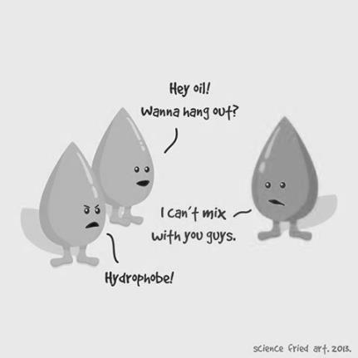
- In terms of polarity, what does “like dissolves like” mean? Give an example from this lab.

