Forensics II: Ballistics Exam Review

- List several things that ballistic evidence can be used to do.

- Explain the history of firearms

- What is rifling? How does this help to link a gun to a crime?

- Describe what is meant by a caliber? How is it determined?

- What is a firing pin mark? How is it used to connect a
firearm to a murder case?
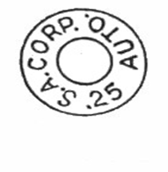

- What is the caliber of the cartridge to the right?

- Explain how trajectory is used to determine the location of a shooter.

- The quote, “Leave the gun, take the cannoli’s,” is from the movie the Godfather.
Name 5 reasons why a mobster would leave the gun at a crime scene.

