Unit 6: Ballistics Notes

History of Gunpowder and Firearms
- The Chinese invented gunpowder over a thousand years ago using KNO₃, charcoal and sulfur.
- Muzzle-loading matchlocks used wicks to ignite the gunpowder.
- The cartridge and breech loading followed.
- Later, flintlock weapons were used using sparks from flint to ignite the gun power (better in wet conditions).
- Gun power was forced down the muzzle (barrel) and packed down.
- Next, cartridges were developed that held the bullet, primer powder, and gun powder.
- A hammer hit the primer powder, the powder exploded to ignite the gunpowder and project the bullet.
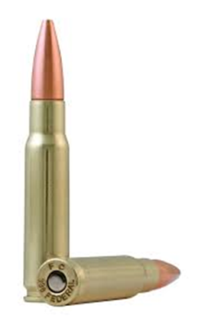
- We still use cartridges today, loaded into the gun opposite the barrel, known as the breech.

Bullets, Cartridges, and Calibers
- Bullets and cartridges are packaged together.
- The bullet, usually of metal, is out front with the cartridge, holding the primer and propellant powders, behind.

How a Firearm Works
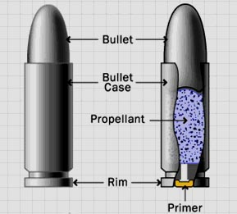
- The firing pin hits the base of the cartridge, igniting the primer powder.
- The primer powder sparks through the flash hole to the main propellant supply.
- The pressure of the explosion pushes the bullet from the casing into the barrel.
- The bullet follows the lands and grooves spiraling out of the barrel.
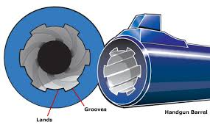

Lands and Grooves
- Rifling allowed the gun to shoot more accurately using
  - Lands: raised areas in the barrel
  - Grooves: indentations in the barrel
- Today, we can look at the lands and grooves to identify the gun

Firearms Now
- Long guns need two hands:
  - Rifles fire bullets
  - Shotguns fire small pellets (shot) or a slug.
- Handguns need only one hand:
  - Pistols are fired with one hand.
  - Colt: Samuel Colt developed a hand gun that shot multiple bullets, known as a revolver. These hold six cartridges.
  - Semiautomatic weapons hold ten cartridges in a magazine or clip. Each pull on the trigger releases one cartridge.
  - Fully Automatic weapons fire for as long as the trigger is pressed.
Caliber of the Cartridge
- Caliber is a measure the diameter of the cartridge.
- These usually are hundredths of an inch.
- Common calibers include .22, .25, .357, .38, .44, and .45.

Marks on the Spent Cartridge Casings
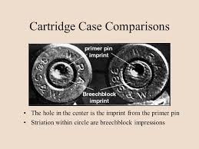
- Firing pin marks on a spent cartridge can be used to match it to a firearm.
- The fire pin marks can appear on the rim or on the center of the spent cartridge.
- Breechblock marks are produced as the cartridge casing slams backward and strikes the breechblock.
- Other marks left on spent cartridge casings include minute scratch extractor and ejector nicks.
- Rifling
  - Grooves cut or formed in a spiral down the barrel of a firearm
  - Increases accuracy and range
  - Types of marks
    - Rifling pattern
    - Breech mark
    - Firing pin impressions
    - Extractor mark
    - Ejector marks

Firearms Examiners will:
- Test firearms
- Test for gunshot residue to determine distance from muzzle to target
- Determine caliber and manufacturer of ammunition components
- Match bullets or cartridge casings to firearms
- Bullet Identification
- Obtain standard from firearm
- Compare crime scene bullet to standard using comparison macroscope
- Unique marks made by imperfections or irregularities = individual evidence
- Firearms Evidence
  - Firearm
  - Fired bullets
  - Spent cartridge cases
  - Spent shot shells
  - Shot
  - Shot shell wadding
  - Live ammunition
  - Gunshot residue (GSR)
  - Clothing

Firearms Database
NIBIN: National Integrated Ballistics Information Network
- Database of images
- Ballistics markings of firearms used in previous crimes
- Cartridge casings

Gunshot Residue
- Particles of unburned powder and traces of smoke are the residues of gunshots.
- They can leave a trace on the hand, arm, face, hair, or clothing of the shooter.
- They can also leave a trace on the victim.
- Chemical testing often can detect residue even if removal is attempted.
- The distance from the victim to the shooter can be determined by examination of the residue pattern on the victim.

Trajectory
- Two reference points are needed to define the trajectory.
- Investigators can figure the shooter discharged the firearm somewhere along that line.
- Reference points can be bullet holes in objects or victims.
- An entry point and exit point on a victim can be used.
- Gunshot residue or spent cartridge casings can be less specific reference points.
- Investigators can use lasers to trace a straight-line path to help determine the position of the shooter.

Bullet Wounds
- Generally, entrance wounds and smaller than exit wounds
- Entrance: skin stretches when bullet enters body
- Exit: bullet carries body tissue and bone with it
- Other signs: fibers in wound, GSR, stippling (burnt skin)
- Pass through: larger bullets, high-speed bullets
- Gunshot Wounds
