Name_________________________ Acid Strength Introduction Activity

Acids are compounds that donate hydrogen ions (H+) in water. Acids (HA) ionize or dissociate in the following ways:
HA → H⁺ + A ⁻¹ or H₂A ↔ HA⁻¹ + H ⁺¹

Certain types of acids can be harmful when contact is made with them. Some acids will burn and cause open wounds when they come in contact with skin or eyes. If consumed they can burn the mouth, throat and stomach, deteriorate teeth and even turn the skin blue.(1) In some cases they can cause death. Other acids will irritate the skin and cause rashes. The amount of damage caused by an acid is determined by how many hydrogen ions are present in solution. The more hydrogen ions present, the worse the effects.

PROCEDURE
Part A: Classifying Acids – For this activity you will find 7 Petri dishes containing 7 different “acids”. These acids include both strong and weak acids. In all of the Petri dishes the black beads represent H ⁺ ions. The other colored beads represent the various anions in the acids. When looking at each of the dishes fill in the information in the table.

Look at the following models in the Petri dishes. Answer the questions for each acid on your data table.  Black = H⁺  Other color = A– (e.g., Br–, ClO₂–) or A^{2–} (e.g., SO₄^{2–})  a. Petri dish = HI  i. For this acid, what does the black bead represent? What does the white bead represent?  ii. Write the ionization reaction for this acid.  __________ → ______ + _______  iii. Record how many of the 10 acid molecules are whole molecules, and how many acid molecules have broken into ions. Determine the percentage that are whole acids and the percentage broken down into ions.  Whole acid molecules _____ Broken into ions ______  % acid = _________ % ions = ________ | 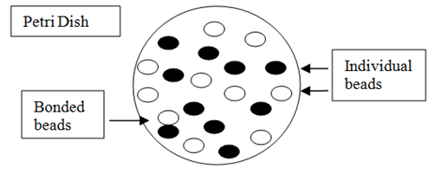  Black bead  White bead

Table 1. Student Data on Acid Ionization
Petri Dish # | Acid Formula | Acid Name | Black  Bead | Other  Bead (color and formula) | Ionization  Reaction | Number of Whole Acid Molecules | Number of Acids ionized | Whole Molecules, % | Acids ionized % | Strong or Weak Acid?
Ex. | HI | Hydoiodic acid | H⁺ | I⁻ | _HI___ → __H⁺__ + _I⁻___ | 1 | 9 | 10 | 90 | strong
1 | HNO₂ |  |  |  | ____ ⇌ ____ + ____
2 | HBr |  |  |  | ____ → ____ + ____
3 | H₂SO₄ |  |  |  | ____ → ____ + ____
4 | HF |  |  |  | ____ ⇌ ____ + ____
5 | H₂CO₃ |  |  |  | ____ ⇌ ____ + ____
6 | HClO₄ |  |  |  | ____ → ____ + ____
7 | H₂SO₃ |  |  |  | ____ ⇌ ____ + ____

Below write Ka expressions for the weak acids above
Questions
1. Looking at your data, what is the relationship between % ionization and acid strength?

2. Compare and contrast diprotic acids and monoprotic acids.

3. A classmate states that H₂CO₃ is a strong acid because it has two hydrogen ions to ionize. Explain why this is an incorrect statement.

4. Draw molecular pictures representing what you would see if the following acids were dissolved in water. Be sure to include correct atomic symbols and charges.

HBrO₄

HCl

H₂S
HNO₃

