Names: _________________________________________ Acid Base Web Quest

Open a browser and go to https://phet.colorado.edu/en/simulation/acid-base-solutions
Play the simulation and choose “introduction”.
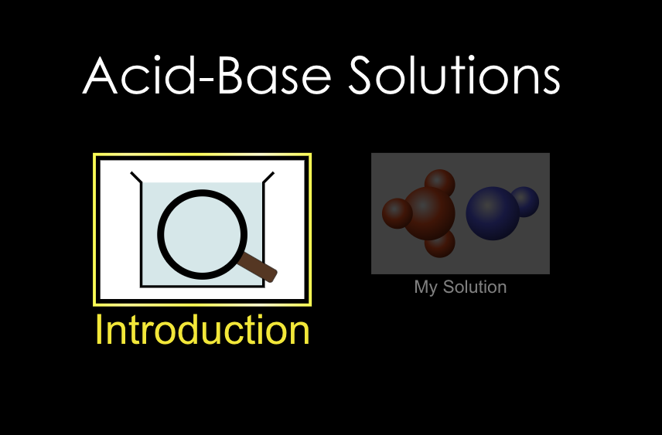
Play with this simulation by changing the solutions on the top right corner, the views on the right side, and using the indication tools on the bottom right of the page. Then answer the questions below. Be sure to move the pH probe (top of screen), litmus, or light bulb (switch at bottom right of screen) into the solution to test. Answer the questions by typing your answer in another color or writing on paper and uploading to Canvas.

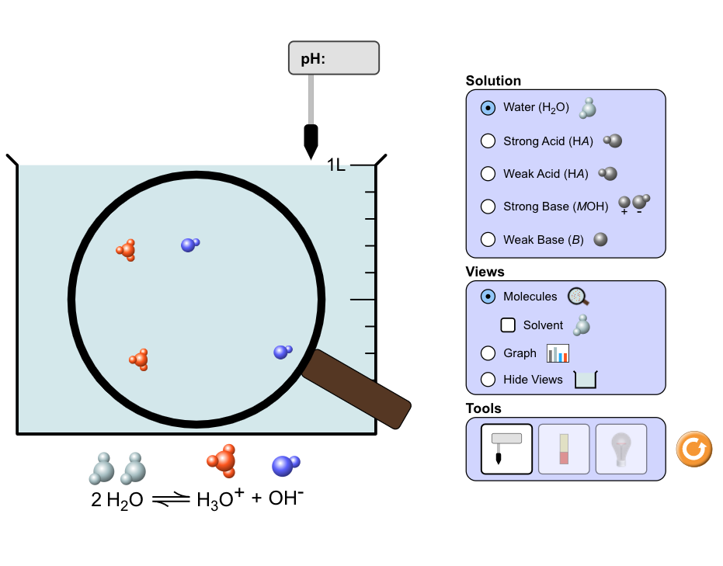
- What ions are present in pure water? (see the reaction on the bottom of the screen)

- Which solution(s) had the most ions dissolved in solution? (choose from the solutions list in the top right corner in purple)

- Which solution(s) has the highest pH? (choose from the solutions list in the top right corner in purple)

- Which solution(s) has the lowest pH? (choose from the solutions list in the top right corner in purple)

- Using pH paper, what color is the strong acid versus the weak acid? (use the middle button on bottom right corner)

- Which solution(s) light the light bulb best? (Use the light bulb on bottom right corner)

- Using the graph (middle purple box on right), which substance is present in the highest concentration for the weak base?

- Using the graph, which substance is present in the highest concentration for the strong acid?

- Explain why the anion and the hydronium ion are equal amounts in the strong acid example.

Now go to the “pH Scale-Macro” simulation under the “Chemistry” simulations https://phet.colorado.edu/en/simulation/ph-scale

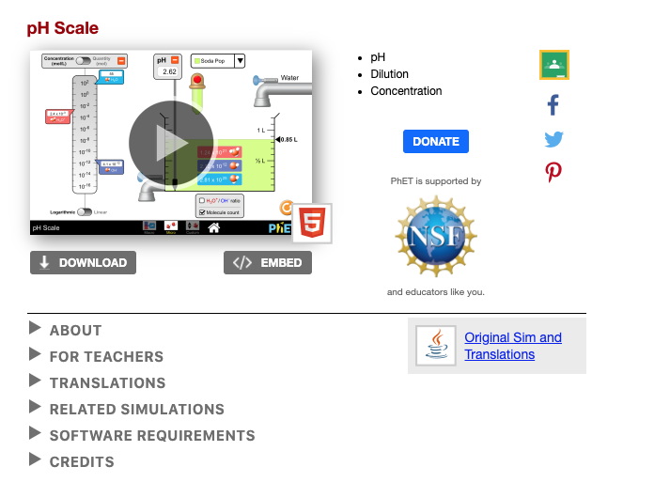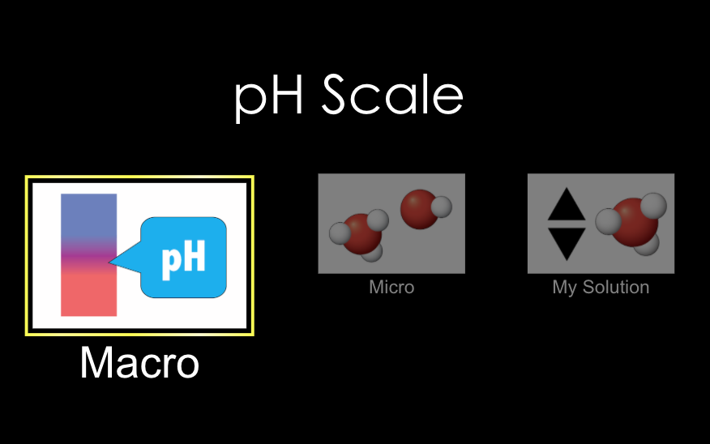

Play with this simulator by changing the solution type on the top of the screen, adding more or less of the solution with the dropper, adding water from the faucet, and using the pH probe (you have to move it into solution).

- Identify each solution’s pH and if it is acidic, basic or neutral.
 | pH | Acidic, Basic, or Neutral?
Drain cleaner
Hand soap
Blood
Spit
Milk
Chicken soup
Coffee
Orange juice
Soda
Vomit
Battery acid
- What happens to the pH of acidic solutions as more of the solution is added? Why?

- What happens to the pH of basic solutions as more of the solution is added? Why?

- What happens to the pH of acidic solutions as water is added? Why?

- What happens to the pH of basic solutions as water is added? Why?

Now go to the “pH Scale-Micro” simulation under the “Chemistry” simulations. https://phet.colorado.edu/sims/html/ph-scale/latest/ph-scale_en.html
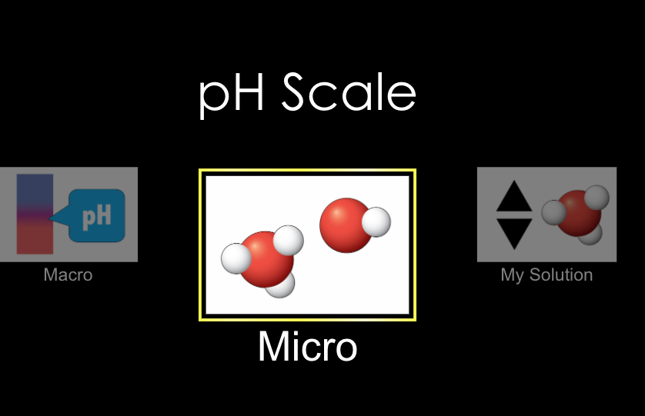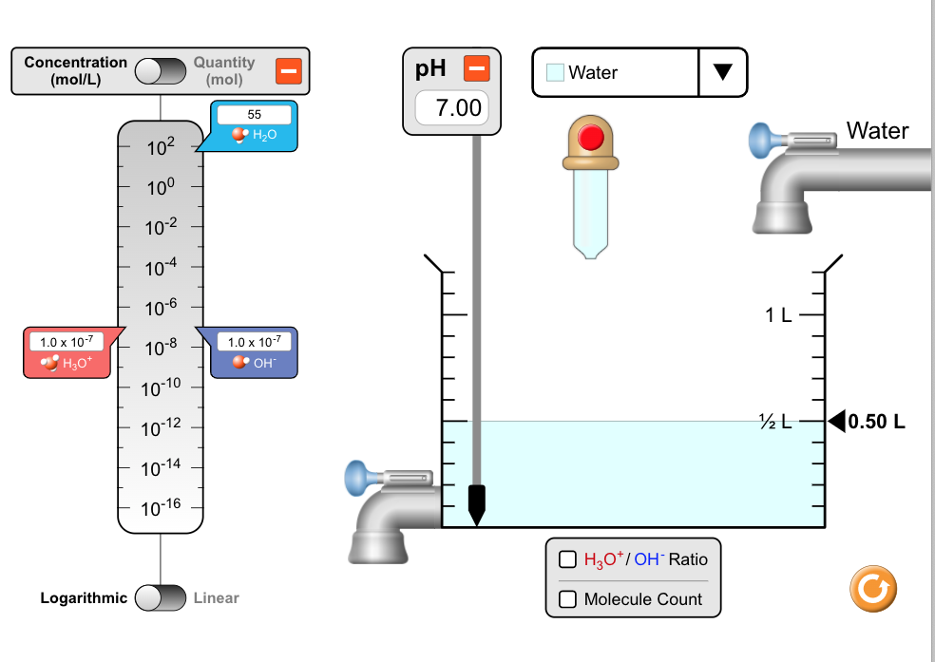

Play with this simulator the same way as before but this time there is also options to view the Molarity, moles, and ratio of the ions on the left side. Keep the scale logarithmic (not linear).

- Record the hydronium concentration, hydroxide concentration and pH for the following:
 | [H₃O⁺] | [OH⁻] | pH
Drain cleaner
Hand soap
Blood
Spit
Milk
Chicken soup
Coffee
Orange juice
Soda
Vomit
Battery acid

- As the hydronium ion concentration increases, what happens to the hydroxide ion concentration? (see the scales on the left)

- In which solution are the amounts of hydronium and hydroxide ions the most equivalent?

- In which solution does the amount of hydronium ions most outweigh the amount of hydroxide ions?

- In which solution does the amount of hydroxide ions most outweigh the amount of hydronium ions?

Now go to the “pH Scale-My Solution” simulation under the “Chemistry” simulations.
https://phet.colorado.edu/sims/html/ph-scale/latest/ph-scale_en.html

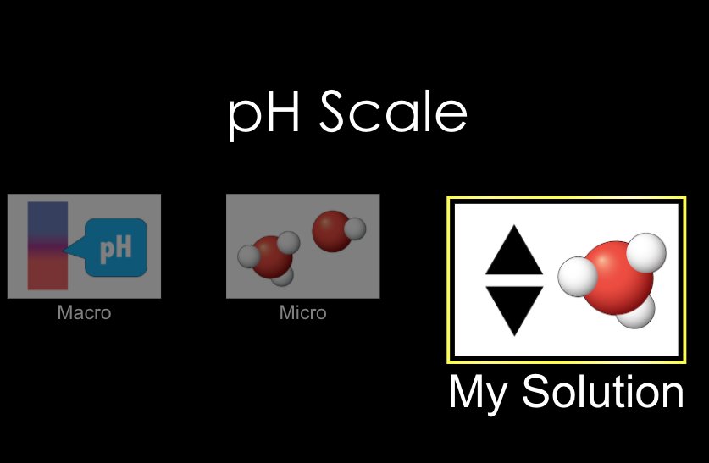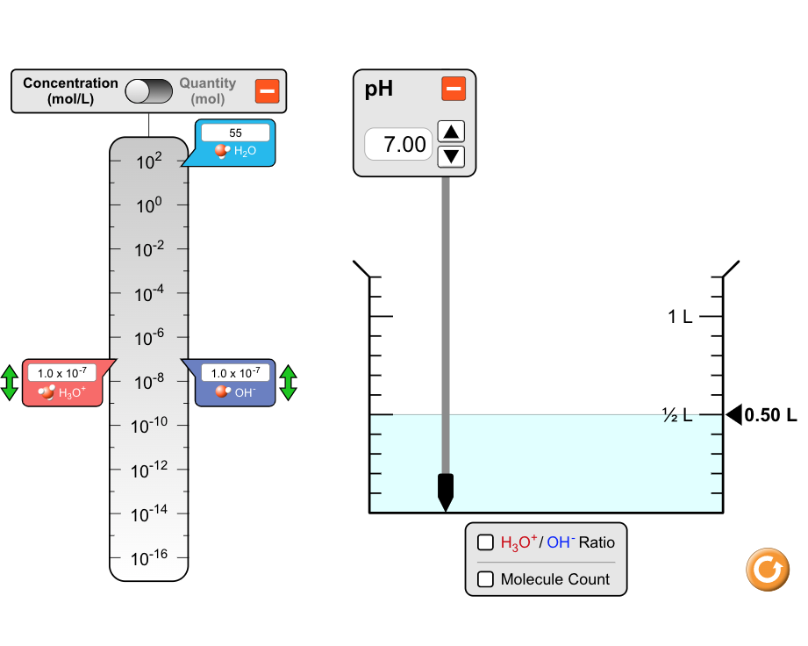

Play with this simulator the same way as before but this time there is also options to create your own solutions.

- For every increase on the pH scale, how does the hydronium ion concentration change?

- For every increase on the pH scale, how does the hydroxide ion concentration change?

