Name: ________________________________ Acid Base Titration Lab

Guiding Question: What is the molarity of the household vinegar?

Background Information: In the chemistry laboratory it is often necessary to find the molarity of an unknown acid or base solution. In order to do this, the scientist must perform a titration. In this procedure, a known solution called the standard solution is used to neutralize a specific volume of the unknown solution to which a few drops of indicator was added. The unknown solution is then added to the standard solution until it has been neutralized. When carrying out the titration, the scientist must know when to stop the addition of the unknown solution. The indicator that was added to one of the solutions should change color at the time when the solutions are neutralized. This is called the end point of the reaction. Now, the number of hydrogen ions should be equal to the number of hydroxide ions. You will use this procedure to determine the molarity of an unknown base.

Materials: Burettes, stands, flasks, graduated cylinders, .100M HCl, unknown NaOH, phenolphthalein, vinegar.

Pre-Lab Questions:
- Why is it important to allow a small amount of the acid and base to pour out of the burette?

- Why is it important to place a white piece of paper beneath the flask?

- Why is it important to go slowly while adding the base drops?

- Is HCl a strong or weak acid? Estimate its pH.

- Is NaOH a strong or weak base? Estimate its pH.

- Write the neutralization reaction for HCl reacting with NaOH. What is their mole ratio?

- What is the pH of the solution at the end point of the titration?

Procedure: WARNING: Wear your goggles at ALL times.
Part A: Titration of NaOH
- Fill burette B with the base. Let about 2-3 mL drain out of each burette and discard. Record the initial base volumes. You may choose to start exactly at 0.00mL.
- Measure 10.0ml of acid in a graduated cylinder. Transfer to the flask. Record the volume of the acid in your data table.
- Add one drop of phenolphthalein to the flask. (Too much could ruin the lab.)
- Place a sheet of white paper under the flask and place the flask under burette B. Place the tip of the burette in the flask.
- Begin the titration by SLOWLY adding the base, drop by drop, while carefully swirling the flask.
- Continue adding the base until a faint pink color appears for at least 15 seconds while stirring.
- Record the burette B reading as the final reading of the base.
- Empty and rinse the flask thoroughly.
- Repeat the procedure for trial 2, using 20mL of acid instead of 10mL.

Part A | Trial 1 |  | Trial 2
 | HCl | NaOH | HCl | NaOH
Initial
Final
Volume used
Part B

Vinegar volume: _____
Initial Base reading: _____
Final Base reading: _____
Total Base volume: _____

Part B: Titration of Vinegar
- Measure out 10mL of white vinegar and place it into a flask. Add 1 drop of phenolphthalein.
- Carefully titrate with the base until the solution turns faint pink for at least 30 seconds. Be sure to write down the initial and final burette readings.

Calculations: SHOW ALL WORK!
- Calculate the molarity of NaOH in part A using the volumes of trial 1 and the known molarity of HCl (0.100M).

- Calculate the molarity of NaOH in part A using the volumes from trial 2 and the known molarity of HCl (0.100M).

- Write a scientific statement explaining if the molarity of the base changes greatly when the volume of the known acid changes.

- Use the average molarity of the base calculated in calculations 1 and 2 to find the molarity of the vinegar in Part B.

- Write a scientific statement comparing the molarities of the HCl and vinegar. Include a claim, evidence from the lab, and reasoning to support your claim.

- Another titration is set up below. The concentration of the acid is unknown.
  - HCl is in the flask. For simplicity, model just the H⁺ ions dissolved in solution: draw five H⁺ ions in the flask. Record the volume of the acid in mL in the table below.
  - A 1.00M NaOH solution is added to the burette. For simplicity we are going to model just the OH⁻ ions. Draw ten OH⁻ ions in the burette. Record the concentration of the base in the table.
  - Record the initial burette volume of NaOH in mL in the data table.
  - The base (OH⁻) is added dropwise into the flask until all of the acid (H⁺) is neutralized by the base. Record the final volume of base in the burette.
  - Subtract to get the total volume of base used to neutralize the acid and record.
  - Draw a final model of the flask when neutralization occurs. Consider conservation of mass!
  - Using the titration formula, determine the unknown concentration of the acid used and record.
Pre-lab and data checked by teacher:

Volume of acid in flask | Concentration of Base (NaOH) | Initial volume of NaOH in buret | Final volume of NaOH in buret | Total Volume of Base Used | Molarity of the Acid

Initial: Final:

0.00 1.00 2.00 3.00 4.00 5.00
6.00
7.00
8.00
0.00 1.00 2.00 3.00 4.00 5.00
6.00
7.00
8.00

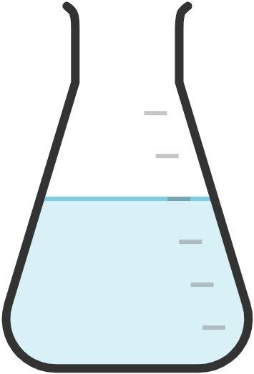

15.0

10.0

5.0

