

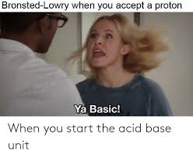

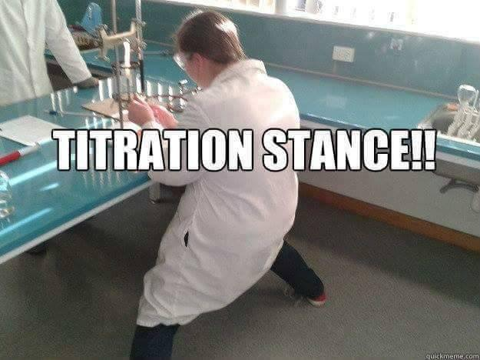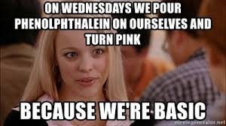

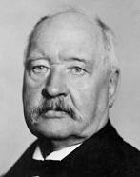**Arrhenius Acid, Bases, and Salts**

1. Use Table K and Table L to help you identify the rules for determining whether a substance is an acid, a base, or a salt based on the formula. Underline all the acids, circle bases, and box in salts. Leave the covalent substances alone.

HF NaCl CH3OH H2SO4 Ca(OH)2 CH4

NH4Br HCl Na2SO4 HNO3 CH3COOH NaOH

H3PO4 LiOH CH2(OH)2 NH4OH Ca(NO3)2 HC2H3O2

* All acids have the ____________ ion in common.
* All bases have the _____________ ion in common.
* All salts have formulas: _________________________________________________________________
* All other compounds have formulas: ______________________________________________________
* Organic acids have the general formula: ________________
* Draw ethanoic acid and circle which H+ ion is lost:

2. Which formula represents a hydronium ion?

(1) H3O+ (2) OH– (3) NH4+ (4) HCO3–

3. Which compound is an Arrhenius acid?

(1) H2SO4 (2) NaOH (3) KCl (4) NH3

4. Which substance is an Arrhenius acid?

(1) Ba(OH)2 (2) H3PO4 (3) CH3COOCH3 (4) NaCl

5. Which compound releases hydroxide ions in an aqueous solution?

(1) CH3COOH (2) HCl (3) CH3OH (4) KOH

6. The Arrhenius theory explains the behavior of

(1) acids and bases

(2) alcohols and amines

(3) isomers and isotopes

(4) metals and nonmetals

7. Which two compounds are electrolytes?

(1) C6H12O6 and CH3CH2OH

(2) C6H12O6 and HCl

(3) NaOH and HCl

(4) NaOH and CH3CHOH

8. Given the equation:

HCl(g) + H2O(l)→X(aq) + Cl−(aq)

Which ion is represented by X?

(1) hydroxide (3) hypochlorite

(2) hydronium (4) perchlorate

9. When one compound dissolves in water, the only positive ion produced in the solution is H3O+(aq). This compound is classified as

(1) a salt (2) a hydrocarbon

(3) an Arrhenius acid (4) an Arrhenius base

10. An aqueous solution of lithium hydroxide contains hydroxide ions as the only negative ion in solution. Lithium hydroxide is classified as an

(1) aldehyde (3) Arrhenius acid

(2) alcohol (4) Arrhenius base

11. Which compound is an Arrhenius acid?

(1) H2SO4  (3) NaOH

(2) KCl (4) NH3

12. An Arrhenius base yields which ion as the only negative ion in an aqueous solution?

(1) hydride ion (3) hydronium ion

(2) hydrogen ion (4) hydroxide ion

13. Which two formulas represent Arrhenius acids?

(1) CH3COOH and CH3CH2OH

(2) HC2H3O2 and H3PO4

(3) KHCO3 and KHSO4

(4) NaSCN and Na2S2O3

14. According to the Arrhenius theory, an acid is a substance that

(1) changes litmus from red to blue

(2) changes phenolphthalein to pink

(3) produces hydronium ions as the only

positive ions in an aqueous solution

(4) produces hydroxide ions as the only

negative ions in an aqueous solution

15. Which formula represents a hydronium ion?

(1) H3O+  (2) OH– (3) NH4+ (4) HCO3–

16. Which substance is an Arrhenius acid?

(1) Mg(OH)2 (2) H2SO4 (3) CH3COOCH3 (4) LiCl

17. Which compound releases hydroxide ions in an aqueous solution?

(1) CH3COOH (2) HF (3) CH3OH (4) LiOH

18. Which substance is an Arrhenius base?

(1) CH3OH (2) LiOH (3) CH3Cl (4) LiCl

19. The only positive ion found in H2SO4(aq) is the

(1) ammonium ion (3) hydronium ion

(2) hydroxide ion (4) sulfate ion

20. Which substance, when dissolved in water, forms a solution that conducts an electric current?

(1) C2H5OH (3) C12H22O11

(2) C6H12O6 (4) CH3COOH

21. Complete the table below using your knowledge of acids, bases, and salts

|  |  |
| --- | --- |
| **Diagram:** | **Experimental:** |
| **Narrative:** |  |

**Strong or Weak, Concentrated or Dilute?**

Directions: For each case, decide if the picture shows a weak or strong, and concentrated or dilute solution.

Acid: H+ ion: Anion A-:

|  |  |  |  |
| --- | --- | --- | --- |
|  |  | **W/S and C/D** | **Example** |
| Case 1 |  |  |  |
| Case 2 |  |  |  |
| Case 3 |  |  |  |
| Case 4 |  |  |  |

5. What does concentrated mean in terms of amount of particles? ____________________________________

6. What does dilute mean in terms of amount of particles?__________________________________________

7. What does strong mean in terms of ions? ______________________________________________________

8. What does weak mean in terms of ions? _______________________________________________________

**Reactions Involving Acids & Bases**

**Neutralization Reactions**: If equal mole amounts of acid and base are added together, the resulting solution is NEUTRAL! )

Acid + Base → Salt + Water

Example: HCl (aq) + NaOH (aq) → NaCl (aq) + H2O (l)

Predict the products of and balance the following reactions:

___ HF (aq) + ___ LiOH (aq) → __________ (aq) + ___ HOH (l)

___ HNO3 (aq) + ___ KOH (aq) → __________(aq) + ___ HOH (l)

___ HCl (aq) + ___ Ca(OH)2 (aq) → __________(aq) + ___ HOH (l)

___ HClO3 (aq) + ___ Mg(OH)2 (aq) → __________(aq) + ___ HOH (l)

___ H2CO3 (aq) + ___ NaOH (aq) → __________(aq) + ___ HOH (l)

___ H2SO4 (aq) + ___ LiOH (aq) → __________ (aq) + ___ HOH (l)

___ H2SO3 (aq) + ___ Ca(OH)2 (aq) → __________(aq) + ___ HOH (l)

___ H3PO3 (aq) + ___ KOH (aq) → __________(aq) + ___ HOH (l)

___ H3PO4 (aq) + ___ Ca(OH)2 (aq) → __________(s) + ___ HOH (l)

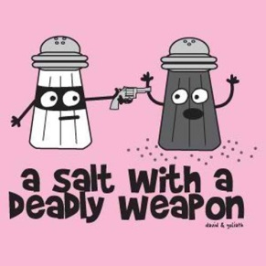**Neutralization reactions are a type of DOUBLE REPLACEMENT reaction**

**Reactions Involving Acids & Bases**

**Reactions of Acids with Metals** (use Table J!) *acid + more active metal 🡪 H2(g) + salt*

Any metal ABOVE H2 in the table will react with acids to produce H2 (g) and a salt.

Any metal below H2 in the table will ­NOT react with an acid (only 3 metals do NOT react with acids: Cu, Au, Ag)

When metals react with acids, this is an example of a SINGLE REPLACEMENT reaction.

Predict the products of the following reactions:

Zn (s) + 2HCl (aq) → _______ + _________

Ag (s) + H2SO4 (aq) → _______ + _________

Ca (s) + H2SO4 (aq) → _______ + _________

1. According to Reference Table J, which of these metals will react most readily with 1.0 M HCl to produce H2(g)?

(1) Ca (2) K (3) Mg (4) Zn

2. Under standard conditions, which metal will react with 0.1 M HCl to liberate hydrogen gas?

(1) Ag (2) Au (3) Cu (4) Mg

3. Because tap water is slightly acidic, water pipes made of iron corrode over time, as shown by the balanced ionic equation below. Explain, in terms of chemical reactivity, why copper pipes are less likely to corrode than iron pipes.

2Fe(s) + 6H+(aq) 🡪 2Fe3+(aq) + 3H2(g)

4. Many ancient cultural statues and buildings were made out of marble. Marble is a type of rock which contains the metal calcium in it. Explain, using Table J, why marble statues are damaged by acid rain.

5. During a laboratory activity, a student reacted a piece of zinc with 0.1 M HCl(aq).

(a) Complete the equation below by writing the formula of the missing products.

Zn + HCl 🡪 ________ + _________

(b) Identify one metal that does not react spontaneously with HCl(aq). _________

**Reactions Regents Questions**

1. What are the products of a reaction between KOH(aq) and HCl(aq)?

(1) H2 and KClO (3) H2O and KCl

(2) KH and HClO (4) KOH and HCl

2. Which word equation represents a neutralization reaction?

(1) base + acid →salt + water

(2) base + salt →water + acid

(3) salt + acid →base + water

(4) salt + water →acid + base

3. Which compound could serve as a reactant in a neutralization reaction?

(1) NaCl (3) CH3OH

(2) KOH (4) CH3CHO

4. Which substance is always a product when an Arrhenius acid in an aqueous solution reacts with an Arrhenius base in an aqueous solution?

(1) HBr (3) KBr

(2) H2O (4) KOH

5. Which reactants form the salt CaSO4(s) in a neutralization reaction?

(1) H2S(g) and Ca(ClO4)2(s)

(2) H2SO3(aq) and Ca(NO3)2(aq)

(3) H2SO4(aq) and Ca(OH)2(aq)

(4) SO2(g) and CaO(s)

6. Sulfuric acid, H2SO4(aq), can be used to neutralize barium hydroxide, Ba(OH)2(aq). What is the formula for the salt produced by this neutralization?

(1) BaS (3) BaSO3

(2) BaSO2 (4) BaSO4

7. Which chemical equation represents the reaction of an Arrhenius acid and an Arrhenius base?

(1) HC2H3O2(aq) + NaOH(aq) 🡪 NaC2H3O2(aq) + H2O(l)

(2) C3H8(g) + 5 O2(g) 🡪 3 CO2(g) + 4 H2O(l)

(3) Zn(s) + 2 HCl(aq) 🡪 ZnCl2(aq) + H2(g)

(4) BaCl2(aq) + Na2SO4(aq) 🡪 BaSO4(s) + 2 NaCl(aq)

When an acid dissolved it dissociates or ionizes (breaking up into two ions). The ions are separated due to the polarity of water, as shown below. Draw what happens to the other acid, base, and salt in water.

NaCl(s) + H2O(l) 🡪 NaCl(aq)



NaOH(s) + H2O(l) 🡪 NaOH(aq)



HNO3(g) + H2O(l) 🡪 HNO3(aq)



HCl(g) + H2O(l) 🡪 HCl(aq)

**Cl-**

+

+

-

**H+**

Explain why they are known as electrolytes when in solution but not when they are in solid or gas phases.

Alternate Theory of Acids and Bases

1. Draw the Lewis electron dot diagram of the following acids and bases:
   1. HCl b. CH3COOH c. NaOH d. LiOH
2. If the compound shown above are polar, add the symbols δ+ and δ- to your structures.
3. Identify whether each of the compounds above are acids or bases.
   1. b. c. d.
4. Compare and contrast the type of bonding found in acids and bases.
5. An unmarked solution of one of these compounds was found at a lab station. What experimental procedures could you do to possibly determine which compound is in the solution?
6. Another solution of aqueous ammonia, NH3 (aq), is tested in the lab.
   1. Draw the Lewis electron dot diagram for NH3.
   2. Predict if the ammonia is acidic or basic using your understanding of bonding.
   3. When tested, ammonia solution turns litmus blue and phenolphthalein turns pink. Using your lab skills, is aqueous ammonia acidic, basic, or neutral?
7. A new theory of acids and bases must be created to include solutions like ammonia.
   1. First, provide a short definition of Arrhenius acids and bases.

Acids: Bases:

* 1. Explain why ammonia, NH3, doesn’t seem to fit this Arrhenius theory.
  2. Explain why a hydrogen ion might be attracted to the ammonia. Use your Lewis electron dot diagrams to help you.

**Bronsted Lowry Theory (Alternate Theory)**

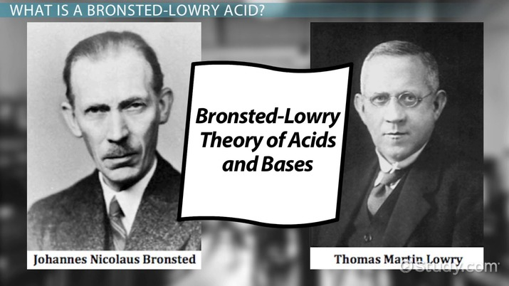

Acids are defined as proton (H+) donators. They donate protons to the base. Bases are defined as proton

acceptors. They accept protons from the acid.

**HBr + NH3 NH4+ + Br-**

According to Bronsted-Lowry theory, acid-base reactions involve a transfer of a proton. Above, the acid on the left, ___________, transfers (donates) a proton (H+) and becomes a base on the right, __________. The donating acid and the base it becomes are called *conjugate acid - base pairs.* The base on the left, __________, accepts a proton (H+) and becomes an acid on the right, _________. This is also a conjugate pair.

**HF(aq) + H2O (l) H3O+(aq) + F-(aq) (1)**

**HI(aq) + NH3(aq) NH4+(aq) + I-(aq) (2)**

**NH4+(aq) + OH-(aq) NH3(aq) + H2O (l) (3)**

**H2O(l) + H2SO (aq) HSO4-(aq) + H3O+(aq) (4)**

1. In the reactions above, label the acids in the reactants and explain what they all have in common.
2. In the reactions above, label the bases in the reactants and explain what they all have in common.
3. If you reverse the equations, label the new acids and bases.
4. Now you can see, that each acid on the left hand side produces a corresponding base on the right hand side. The base is called the **conjugate base**. Similarly, a base on the right hand side will produce a **conjugate acid**. These pairs are known as **conjugate acid-base pairs**. List the conjugate acid-base pairs for equations (1) and (2).
5. Write the acid-base reaction for NH3 reacting with HCl and label the acid, the base, the conjugate acid and the conjugate base.
6. Draw Lewis electron dot diagrams with charges and partial charges (δ+) of each of the compounds above to show the transfer of the H+ ion in this reaction.

___6. One acid-base theory defines a base as an

(1) H+ donor (2) H donor (3) H+ acceptor (4) H acceptor

___7. One alternate acid-base theory states that an acid is a(n)

(1) H+ donor (2) OH− donor (3) H+ acceptor (4) OH− acceptor

___8. According to one acid-base theory, a water molecule acts as an acid when the water molecule

(1) accepts an H+ (2) accepts an OH– (3) donates an H+ (4) donates an OH–

___9. Given the equation representing a reaction at equilibrium:

**NH3(g) + H2O(l) 🡨🡪 NH4+(aq) + OH–(aq)**

The H+ acceptor for the forward reaction is

(1) H2O (l) (2) NH4+ (aq) (3) NH3 (g) (4) OH– (aq)

___10. Which formula represents a hydronium ion?

(1) H3O+ (2) OH– (3) NH4+ (4) HCO3–

___11. Given the balanced equation representing a reaction:

**NH3(g) + H2O (l) 🡨🡪 NH4+(aq) + OH–(aq)**

According to one acid-base theory, the NH3(g) molecules act as

(1) an acid because they accept H+ ions

(2) an acid because they donate H+ ions

(3) a base because they accept H+ ions

(4) a base because they donate H+ ions

___12. Which statement describes an alternate theory of acids and bases?

(1) Acids and bases are both H+ acceptors.

(2) Acids and bases are both H+donors.

(3) Acids are H+ acceptors, and bases are H+ donors.

(4) Acids are H+ donors, and bases are H+ acceptors.

___13 Which substance, when dissolved in water, forms a solution that conducts an electric current?  
(1) C2H5OH (2) C12H22O11 (3) C6H12O6  (4) CH3COOH

**The pH Scale**

**The pH scale is a measure of the H+ or H3O+ concentration in a solution. “pH” stands for “potential to ATTRACT Hydrogen ions” “potential to ATTRACT Hydrogen ions**

* **Acids have a LOW pH (a LOW potential to attract H+ ions (release/DONATE H+)**
* **Bases have a HIGH pH (a HIGH potential to attract H+ ions (bases are H+ acceptors)**

**The pH scale is logarithmic: a change of *one* pH unit will change the concentration of H+ by a factor of 10.**

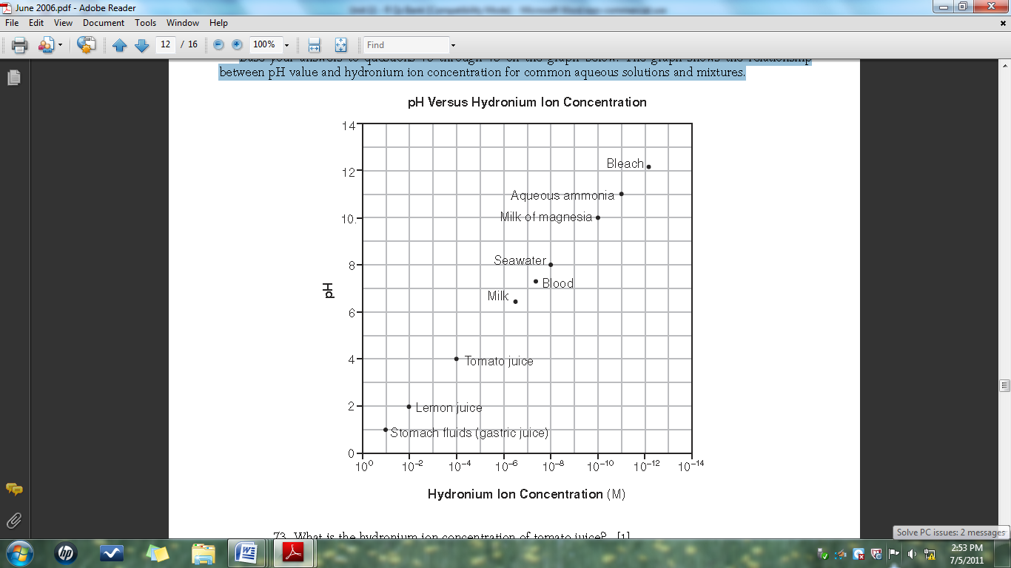

1. What is the relationship between pH value and hydrogen ion concentration?

2. Which substance is 10000 times more acidic than seawater?

3. What substance is 100 times more basic than lemon juice?

3. Complete the table below using the grid above:

|  |  |  |  |
| --- | --- | --- | --- |
|  | **Hydronium Ion Concentration (M)** | **pH** | **Acid or Base?** |
| Stomach fluids |  |  |  |
| Lemon Juice |  |  |  |
| Tomato Juice |  |  |  |
| Milk |  |  |  |
| Blood |  |  |  |
| Seawater |  |  |  |
| Milk of Magnesia |  |  |  |
| Aqueous Ammonia |  |  |  |
| Bleach |  |  |  |

4. Find the pH of the following solutions and determine if its acidic or basic:

|  |  |  |
| --- | --- | --- |
| **Acid Concentration** | **pH** | **Acid or Base? (or neutral ☺)** |
| [H3O+] = 1x10-2 |  |  |
| [H3O+] = 1x10-7 |  |  |
| [H3O+] = 1x10-10 |  |  |
| [H+] = 1x10-11 |  |  |
| [H+] = 1x10-5 |  |  |
| [H3O+] = 0.0010 |  |  |
| [H3O+] = 0.0000010 |  |  |
| [H+] = 0.0000000010 |  |  |

**Recall the following:**

* + - * **increasing or decreasing the pH by 1 changes the [H+] by a factor of 101 (10 times, ten-fold)**
      * **increasing or decreasing the pH by 2 changes the [H+] by a factor of 102(100 times, hundred-fold)**
      * **increasing or decreasing the pH by 3 changes the [H+] by a factor of 103 (1000, thousand-fold)**

1. Describe what happens to the concentration of hydrogen ions in a solution if the pH is changed from 7 to 5.

1. Describe what is happening to the concentration of hydrogen ions in a solution if the pH is changed from 5 to 8.
2. Complete the table below:

|  |  |  |  |  |
| --- | --- | --- | --- | --- |
| pH Change | [H3O+] increase or decrease? | [OH-] increase or decrease? | Does the solution become more acidic or basic? | By a factor of… |
| 6 to 8 |  |  |  |  |
| 8 to 5 |  |  |  |  |
| 3 to 7 |  |  |  |  |
| 11 to 9 |  |  |  |  |
| 14 to 13 |  |  |  |  |
| 4 to 8 |  |  |  |  |

8. Which of these pH numbers indicates the highest

level of acidity?

(1) 5 (2) 10 (3) 8 (4) 12

9. Which change in pH represents a hundredfold increase in the concentration of hydronium ions?

(1) pH 1 to pH 2 (3) pH 2 to pH 1

(2) pH 1 to pH 3 (4) pH 3 to pH 1

10. The pH of a solution changes from 4 to 3 when the hydrogen ion concentration in the solution is

(1) decreased by a factor of 100

(2) decreased by a factor of 10

(3) increased by a factor of 100

(4) increased by a factor of 10

11. Solution A has a pH of three and solution Z has a pH of six How many times greater is the hydronium ion concentration in solution A than the hydronium ion concentration in solution Z?

(1) 100 (2) 3 (3) 2 (4) 1000

12. What is the pH of a solution that has a hydronium ion concentration 100 times greater than a solution with a pH of 4?

(1) 5 (2) 3 (3) 2 (4) 6

**Honors pH Activity**

Directions: No work needed but report answers with proper significant figures and units.

|  |  |  |  |  |  |  |  |
| --- | --- | --- | --- | --- | --- | --- | --- |
| **Solution** | **pH** | **pOH** | **[H+]** | **[OH-]** | **[H+]x[OH-]** | **pH + pOH** | **A/B/N?** |
|  |  |  |  |  |  |  |  |
|  |  |  |  |  |  |  |  |
|  |  |  |  |  |  |  |  |
|  |  |  |  |  |  |  |  |
|  |  |  |  |  |  |  |  |
|  |  |  |  |  |  |  |  |
|  |  |  |  |  |  |  |  |
|  |  |  |  |  |  |  |  |

1. Describe the relationship between the strength of acids, H+ and OH-concentration, and pH/pOH.
2. Describe the relationship between the strength of bases, H+ and OH-concentration, and pH/pOH.
3. If the pOH of a solution is 5 find the pH, [H+], and [OH-]. Is it an acid, base, or neutral?
4. If the [H+] of a solution is 1x10-5 find the pH, pOH, and [OH-]. Is it an acid, base, or neutral?
5. If the [OH-] of a solution is 1x10-4 find the pH, pOH, and [H+]. Is it an acid, base, or neutral?

**Honors Acid Base Practice**

1. The equation for the auto-ionization of water can be written as: H2O + H2O ⇐⇒ H3O+ + OH–

At room temperature, Kw = 1 × 10–14. Write the expression for the equilibrium constant for this reaction, calculate the concentration of the ions and explain why the pH of water is 7.

1. Suppose the [H3O+] were increased to 1.0 × 10–3 M by the addition of acid. Calculate the [OH–] in solution.
2. Suppose the [OH–] were increased to 2.5 × 10–3 M by the addition of base. Calculate the [H3O+].
3. Determine the pH of the solutions in Q2 and Q3. Determine the pOH of these solutions.
4. The hydrogen ion concentration of several foods was measured with the following results. Bananas have a [H3O+] of 2.5 × 10–5 M. Pickles have a [OH–] of 8.3 × 10-11 M and milk has a pH of 6.4. List the foods in order from **most basic** to **most acidic**.
5. The pH of a solution is 3.8. Calculate the [H+], [OH–] and pOH.
6. The pH of the blood plasma is regulated between a very narrow range (7.35 - 7.45). One of the equilibrium systems that helps to manage this is: 2 H2O + CO2 ⇐⇒ 2 H2CO3 ⇐⇒ H3O+ + HCO3–  A person whose blood pH gets too low tends to hyperventilate, blowing off CO2 gas in the process. Explain how the loss of CO2 can raise the blood pH.
7. The pH of cider vinegar is approximately 5, whereas the pH of a freshly opened can of Coca-Cola is approximately 2.5. How many times greater is the [H3O+] in the Coke than in the vinegar?
8. After a while, an open can of a carbonated soft drink goes flat. How would this change the pH of the beverage if at all? Explain.

**Indicators**

**How to use Table M:**

* If the pH is below the first number, the solution will be the first color listed
* If the pH is above the second number, the solution will be the second color listed
* If the pH is between the numbers, the solution will be a mix of the two colors

Table M

Ex: If you add bromthymol blue… to a solution with a pH of 8, it will be blue

to a solution with a pH of 6, it will be green

to a solution with a pH of 4, it will be yellow

1. Which indicator, when added to a solution, changes color from yellow to blue as the pH of the solution is changed from 5.5 to 8.0?

(1) bromcresol green

(2) bromthymol blue

(3) litmus

(4) methyl orange

2. Which indicator would best distinguish between a solution with a pH of 3.5 and another with a pH of 5.5?

(1) bromthymol blue (3) litmus

(2) bromcresol green (4) thymol blue

3. In which solution will bromcresol green appear blue?

(1) 1 M NaCl (3) 1 M NH3

(2) 1 M H2CO3 (4) 1 M CH3COOH

4. In which solution will thymol blue indicator appear blue?

(1) 0.1 M CH3COOH (3) 0.1 M KOH

(2) 0.1 M HCl (4) 0.1 M H2SO4

5. What is the color of the indicator methyl orange in a solution that has a pH of 2?

(1) blue (3) yellow

(2) orange (4) red

6. In a solution with a pH of 3, what color is bromcresol green?

(1) yellow (3) green

(2) blue (4) red

7. At what pH will bromothymol blue be yellow and bromocrescol gree be blue?

(1) 10.5 (2) 5.7 (3) 7.0

8. A student used blue litmus paper and phenolphthalein paper as indicators to test the pH of distilled water and five aqueous household solutions. Then the student used a pH meter to measure the pH of the distilled water and each solution. The results of the student’s work are recorded in the table below.



1. Identify the liquid tested that has the lowest hydronium ion concentration.
2. Explain, in terms of the pH range for color change on Reference Table M, why litmus is not appropriate to differentiate the acidity levels of tomato juice and vinegar.
3. Based on the measured pH values, identify the liquid tested that is 10 times more acidic than vinegar.

**Honors Acid Equilibrium**

1. For each acid dissociation below, write the Ka, equilibrium expression. Then choose:
   1. The strongest acid
   2. The acid that produces the lowest concentration of hydronium ions per mole of acid

HNO3(aq) + H2O(l) arrow H3O+(aq) + NO3-(aq) Ka = very large

HSO4-(aq) + H2O(l) arrow H3O+(aq) + SO4--2(aq) Ka = 1.2 x 10-2

HCN(aq) + H2O(l) arrow H3O+(aq) + CN- (aq) Ka = 4.0 x 10-10

H2CO3(aq) + H2O(l) arrow H3O+(aq) + HCO3-(aq) Ka = 4.2 x 10-7

NH4+(aq) + H2O(l) arrow H3O+(aq) + NH3(aq) Ka = 5.6 x 10-10

HF(aq) + H2O(l) arrow H3O+(aq) + F- (aq) Ka = 7.2 x 10-4

2. Suppose you dissolved benzoic acid in water to make a 0.15 M solution. What is:

a. the concentration of benzoic acid? Ka for benzoic acid = 6.3 x 10-5

b. the concentration of hydronium ion?

c. the concentration of benzoate anion?

d. the pH of the solution?

3. Calculate the pH of a 0.20 M solution of HCN. (Ka HCN = 4.9 x 10 -10)

4. Calculate the pH of a 0.020M solution of HCN. The Ka is 4.9x10-10. Compare to question 3.

5. The Ka for niacin is 1.6x10-5. Calculate the pH of 0.0100M solution.

6. A 0.12 M solution of an unknown weak acid has a pH of 4.26 at 25°C. What is the hydronium ion concentration in the solution and what is the value of its Ka?

7. The pH of a 0.115M solution of chloroacetic acid, ClCH2COOH, is measured to be 1.92. Calculate Ka.

8. Calculate the concentration of OH- and pH of a 0.15M solution of NH3. Kb = 1.8x10-5

9. Hydroxylamine is a weak base with a Kb = 6.6 x 10-9. What is the pH of a 0.36 M solution of hydroxylamine in water at 25°C?

10. Calculate the pOH and pH of 0.15M NH3 solution if the Kb is 1x10-5.

**Titrations**

Titrations are procedures used to determine the concentration (M) of an acid or a base. You combine together an acid and a base knowing the volume of each and the concentration of only one of them.

1. What number would be at the top of the buret?
2. Read the volume of the base in the buret.
3. If the buret holds 50mL, how much base is actually in the buret?
4. If a student started at 2.0mL and released base until it was at the level shown, how much bases was added?
5. Why is it not necessary to subtract all your volumes from 50mL?

**Titration setup**

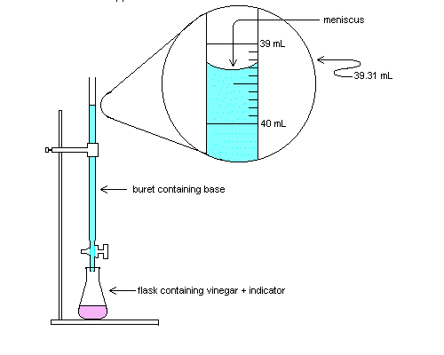

buret containing BASE

Erlenmeyer flask containing ACID AND an indicator

buret containing BASE

Using the equation on Reference Table T, you can solve for either the molarity/concentration (M) or a volume added (V).

MA VA = MB VB

MA= molarity of H+ VA = volume of acid

MB = molarity of OH– VB = volume of base

1. A 25.0-milliliter sample of HNO3 (aq) is neutralized by 32.1 milliliters of 0.150 M KOH (aq). What is the concentration of the acid?

2. How many milliliters of 0.200 M NaOH are needed to neutralize 100. mL of 0.100 M HCl?

3. In a titration, 20.0 milliliters of 0.15 M HCl(aq) is exactly neutralized by 18.0 milliliters of KOH(aq).

1. Complete the equation belowfor the neutralization reaction by writing the formula of *each* product.

KOH(aq) + HCl(aq) → _________ + _________

1. Compare the number of moles of H+(aq) ions to the number of moles of OH– (aq) ions in the

titration mixture when the HCl(aq) is exactly neutralized by the KOH(aq).

1. Determine the concentration of the KOH(aq).
2. What is the new pH of the solution?
3. In a laboratory activity, 0.500 mole of NaOH(s) is completely dissolved in distilled water to form 400. milliliters of NaOH(aq). This solution is then used to titrate a solution of HNO3(aq).
4. Identify the negative ion produced when the NaOH(s) is dissolved in distilled water.

1. Calculate the molarity of the NaOH(aq). Your response must include *both* a correct numerical setup and the calculated result.

1. If 26.4 milliliters of the NaOH solution is needed to exactly neutralize 44.0 milliliters of the HNO3 solution, what is the molarity of the HNO3 solution?
2. Complete the equation below representing this titration reaction by writing the formulas of the products.

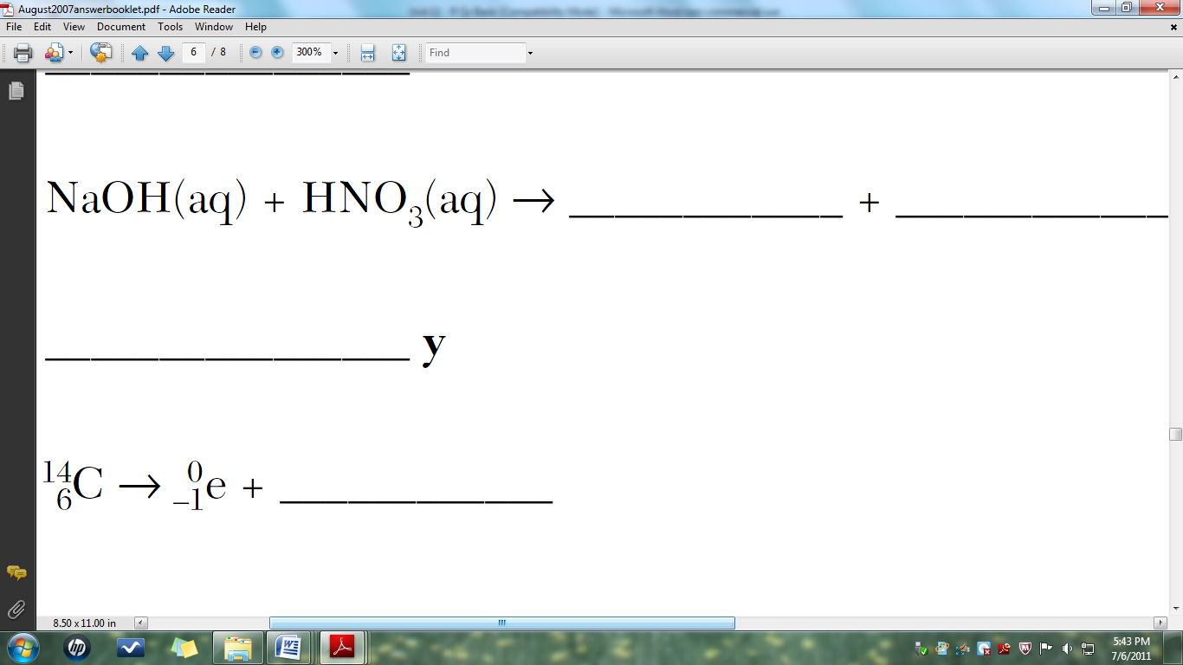

**Neutralization by Titration Practice**

**H3PO4 + H2O 🡪 3H3O+ + PO4-3 H2SO4 + H2O 🡪 2H3O+ + SO4-2**

What happens when an acid has two or more hydrogen atoms? Do they just lose one? Strong acids completely ionize leaving no hydrogen atoms in the anion or conjugate base. This means we need to amend out titration formula for these special acids to include all the acidic ions that come off.

**Ca(OH)2 + H2O 🡪 2OH- + Ca+2 Mg(OH)2 + H2O 🡪 2OH- + Mg+2**

Similarly, what happens when a base has two or more hydroxide ions? Do they just lose one? Strong bases completely ionize leaving no hydroxide ions in the cation. This means we need to amend out titration formula for these special bases to include all the basic ions that come off.

The MaVa = MbVb formula will have coefficients in front of the M corresponding to the number of H+ or OH- in the acid and base formula.

Example: If 35.0mL of 3.00M H3PO4 is neutralized by 50.0mL of Ca(OH)2, what is the molarity of the base?

**MaVa = MbVb becomes3 Ma Va = 2 Mb Vb**

**3(3)(35) = 2(x)(50)**

**x = 3.15M**

1. If 65.0mL of 1.50M H3PO4 is neutralized by 25.0mL of Ca(OH)2, what is the molarity of the base?

2. If 15.0mL of 3.50M H2SO4 is neutralized by 25.0mL of Mg(OH)2, what is the molarity of the base?

3. If 150.0mL of 4.50M HNO3 is neutralized by 3.00M Mg(OH)2, what is the volume of the base added?

4. If 25.5mL H3PO4 is neutralized by 50.0mL of 2.00M LiOH, what is the molarity of the acid?

5. If 35.0mL of H2CO3 is neutralized by 50.0mL of 1.50M KOH, what is the molarity of the acid?

6. If 6.00M HI is neutralized by 50.0mL of 4.50M RbOH, what is the volume of the acid added?

**Regents Titration Questions**

1. What are the products of a reaction between LiOH(aq) and HCl(aq)?

(1) H2 and LiClO (2) H2O and LiCl

(3) LiH and HClO (4) LiOH and HCl

2. Which word equation represents a neutralization reaction?

(1) salt + acid →base + water

(2) base + salt →water + acid

(3) base + acid →salt + water

(4) salt + water →acid + base

3. Which compound could serve as a reactant in a neutralization reaction?

(1) HCl (3) CH3OH

(2) HOH (4) H2O

4. Which substance is always a product when an Arrhenius acid in an aqueous solution reacts with an Arrhenius base in an aqueous solution?

(1) HF (3) KBr

(2) H2O (4) LiOH

5. Which reactants form the salt MgSO4(s) in a neutralization reaction?

(1) H2S(g) and Mg(ClO4)2(s)

(2) H2SO3(aq) and Mg(NO3)2(aq)

(3) H2SO4(aq) and Mg(OH)2(aq)

(4) SO2(g) and MgO(s)

6. Sulfuric acid, H2SO4(aq), can be used to neutralize barium hydroxide, Ca(OH)2(aq). What is the formula for the salt produced by this neutralization?

(1) CaS (3) CaSO3

(2) CaSO2 (4) CaSO4

7. Which chemical equation represents the reaction of an Arrhenius acid and an Arrhenius base?

(1) HCl + NaOH🡪 NaCl + H2O

(2) C3H8+ 5 O2 🡪3 CO2 + 4 H2O

(3) Zn + 2 HCl🡪 ZnCl2 + H2

(4) Ba(OH)2 + Na2SO4 🡪 BaSO4 + 2 NaOH

8. Which volume of 0.10 M NaOH(aq) exactly neutralizes 15.0 milliliters of 0.20 M HNO3(aq)?

(1) 1.5 mL (3) 3.0 mL

(2) 7.5 mL (4) 30. mL

9. In which laboratory process could a student use 0.10 M NaOH(aq) to determine the concentration of an aqueous solution of HBr?

(1) chromatography

(2) decomposition of the solute

(3) evaporation of the solvent

(4) titration

10. The data collected from a laboratory titration are used to calculate the

(1) rate of a chemical reaction

(2) heat of a chemical reaction

(3) concentration of a solution

(4) boiling point of a solution

11. Which volume of 0.10 M NaOH(aq) exactly neutralizes 15.0 milliliters of 0.020 M HNO3(aq)?

(1) 1.5 mL (3) 3.0 mL

(2) 7.5 mL (4) 30. mL

12. What volume of 0.120 M HNO3(aq) is needed to completely neutralize 150.0 milliliters of 0.100 M NaOH(aq)?

(1) 62.5 mL (3) 180. mL

(2) 125 mL (4) 360. mL

13. A 25.0-milliliter sample of HNO3(aq) is neutralized by 32.1 milliliters of 0.150 M KOH(aq). What is the molarity of the HNO3(aq)?

14. A 25.0 mL sample of 5.00 M HCl is required to neutralize 34.5 mL of NaOH solution, what is the concentration of the NaOH solution?

15. A total of 50.0 mL of 0.50 M KOH solution completely neutralizes 125 mL of hydrobromic acid solution (HBr). Calculate the concentration of the HBr solution.

16. What volume of 0.10 M NaOH(aq) exactly neutralizes 15.0 milliliters of 0.20 M HNO3(aq)?

17. What volume of 0.05 M HI is required to neutralize 50 ml of 0.01 M NaOH solution?

18. What volume of 0.500 M HNO3(aq) must completely react to neutralize 100.0 milliliters of 0.100 M KOH(aq)?

19. In a titration, 15.65 milliliters of a KOH(aq) solution exactly neutralized 10.00 milliliters of a 1.22 M HCl(aq) solution.

1. Write the balanced equation for the titration reaction.

(b) Show a correct numerical setup for calculating the molarity of the KOH(aq) solution.

20. In performing a titration, a student adds three drops of phenolphthalein to a flask containing 25.00 milliliters of HCl(aq). Using a buret, the student slowly adds 0.150 M NaOH(aq) to the flask until one drop causes the indicator to turn light pink. The student determines that a total volume of 20.20 milliliters of NaOH(aq) was used in this titration.

(a) The concentration of the NaOH(aq) used in the titration is expressed to what number of significant figures?

(b) Calculate the molarity of the HCl(aq) used in this titration. Your response must include both a correct numerical setup and the calculated result.

**Our Model so far…**

Complete the table below using your knowledge of titrations, indicators, and neutralization.

|  |  |
| --- | --- |
| **Diagram:** | **Experimental:** |
| **Graphical:** | **Narrative:** |

Honors Titration Graphs

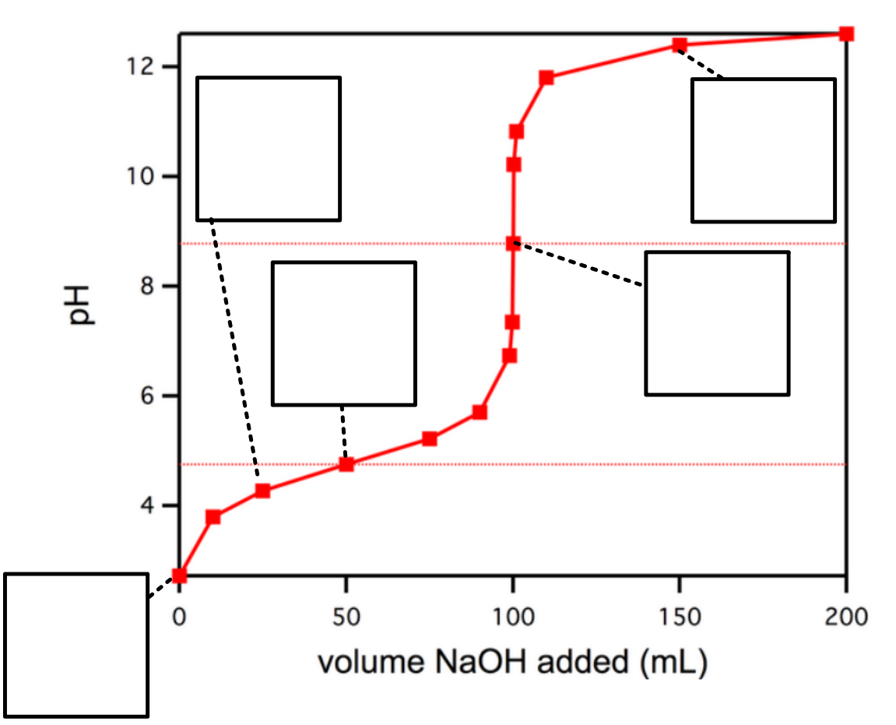

Honors Titration Curve Introduction

Consider a 10. L sample of 0.10 M HCl.

_____ a) What is the pH of the solution?

_____ b) How many mL of 0.10 M NaOH would be required to neutralize it?

_____ c) What is the pH of the neutralized solution?

_____ d) What would the pH of the solution be if you added 20. L of NaOH?

|  |  |  |  |  |  |  |  |
| --- | --- | --- | --- | --- | --- | --- | --- |
| **liters of**  **0.10 M HCl** | **liters of**  **0.10 M NaOH** | **moles**  **of H+** | **moles**  **of OH-** | **moles of XS H+ or OH-** | **total**  **volume** | **[H+] or [OH-]** | **pH** |
| **10.** | **20.** |  |  |  |  |  |  |

Let’s do this more carefully:

|  |  |  |  |  |  |  |  |
| --- | --- | --- | --- | --- | --- | --- | --- |
| **liters of**  **0.10 M HCl** | **liters of**  **0.10 M NaOH** | **moles**  **of H+** | **moles**  **of OH-** | **moles of XS H+ or OH-** | **total**  **volume** | **[H+] or [OH-]** | **pH** |
| **10.** | **0.0** |  |  |  |  |  |  |
| **10.** | **1.0** |  |  |  |  |  |  |
| **10.** | **2.0** |  |  |  |  |  |  |
| **10.** | **3.0** |  |  |  |  |  |  |
| **10.** | **4.0** |  |  |  |  |  |  |
| **10.** | **5.0** |  |  |  |  |  |  |
| **10.** | **6.0** |  |  |  |  |  |  |
| **10.** | **7.0** |  |  |  |  |  |  |
| **10.** | **8.0** |  |  |  |  |  |  |
| **10.** | **9.0** |  |  |  |  |  |  |
| **10.** | **10.** |  |  |  |  |  |  |
| **10.** | **11** |  |  |  |  |  |  |
| **10.** | **12** |  |  |  |  |  |  |
| **10.** | **13** |  |  |  |  |  |  |
| **10.** | **14** |  |  |  |  |  |  |
| **10.** | **15** |  |  |  |  |  |  |
| **10.** | **16** |  |  |  |  |  |  |
| **10.** | **17** |  |  |  |  |  |  |
| **10.** | **18** |  |  |  |  |  |  |
| **10.** | **19** |  |  |  |  |  |  |
| **10.** | **20.** |  |  |  |  |  |  |

Graph this data: x = **Volume of NaOH added** and y = **pH**. This is called a “**titration curve**.”

|  |  |  |  |  |  |  |  |  |  |  |  |  |  |  |  |  |  |  |  |  |  |  |  |  |  |
| --- | --- | --- | --- | --- | --- | --- | --- | --- | --- | --- | --- | --- | --- | --- | --- | --- | --- | --- | --- | --- | --- | --- | --- | --- | --- |
|  |  |  |  |  |  |  |  |  |  |  |  |  |  |  |  |  |  |  |  |  |  |  |  |  |  |
|  |  |  |  |  |  |  |  |  |  |  |  |  |  |  |  |  |  |  |  |  |  |  |  |  |  |
|  |  |  |  |  |  |  |  |  |  |  |  |  |  |  |  |  |  |  |  |  |  |  |  |  |  |
|  |  |  |  |  |  |  |  |  |  |  |  |  |  |  |  |  |  |  |  |  |  |  |  |  |  |
|  |  |  |  |  |  |  |  |  |  |  |  |  |  |  |  |  |  |  |  |  |  |  |  |  |  |
|  |  |  |  |  |  |  |  |  |  |  |  |  |  |  |  |  |  |  |  |  |  |  |  |  |  |
|  |  |  |  |  |  |  |  |  |  |  |  |  |  |  |  |  |  |  |  |  |  |  |  |  |  |
|  |  |  |  |  |  |  |  |  |  |  |  |  |  |  |  |  |  |  |  |  |  |  |  |  |  |
|  |  |  |  |  |  |  |  |  |  |  |  |  |  |  |  |  |  |  |  |  |  |  |  |  |  |
|  |  |  |  |  |  |  |  |  |  |  |  |  |  |  |  |  |  |  |  |  |  |  |  |  |  |
|  |  |  |  |  |  |  |  |  |  |  |  |  |  |  |  |  |  |  |  |  |  |  |  |  |  |
|  |  |  |  |  |  |  |  |  |  |  |  |  |  |  |  |  |  |  |  |  |  |  |  |  |  |
|  |  |  |  |  |  |  |  |  |  |  |  |  |  |  |  |  |  |  |  |  |  |  |  |  |  |
|  |  |  |  |  |  |  |  |  |  |  |  |  |  |  |  |  |  |  |  |  |  |  |  |  |  |
|  |  |  |  |  |  |  |  |  |  |  |  |  |  |  |  |  |  |  |  |  |  |  |  |  |  |
|  |  |  |  |  |  |  |  |  |  |  |  |  |  |  |  |  |  |  |  |  |  |  |  |  |  |
|  |  |  |  |  |  |  |  |  |  |  |  |  |  |  |  |  |  |  |  |  |  |  |  |  |  |
|  |  |  |  |  |  |  |  |  |  |  |  |  |  |  |  |  |  |  |  |  |  |  |  |  |  |
|  |  |  |  |  |  |  |  |  |  |  |  |  |  |  |  |  |  |  |  |  |  |  |  |  |  |
|  |  |  |  |  |  |  |  |  |  |  |  |  |  |  |  |  |  |  |  |  |  |  |  |  |  |

**Questions:**

1. At what point on this curve is the acid neutralized?

2. What would a graph of the **slope of this curve** vs. **Volume of NaOH added** look like?

Sketch it over your titration curve.

3. Identify the “equivalence point” on your titration curve and on the sketch of the slope vs. NaOH.

4. Phenolphthalein is an acid-base indicator that changes color at pH of 8. It is commonly used for this titration. Indicate on your graph when the phenolphthalein will change color.

Honors Titration Curves

For the following titration curves identify which of the following it can be defined as:

1. Strong acid titrated with strong base
2. Strong acid titrated with weak base
3. Weak acid titrated with strong base
4. Strong base titrated with a strong acid
5. Strong base titrated with a weak acid
6. Weak base titrated with strong acid

In addition, find and label the equivalence point(s) and predict an indicator that can be used in this titration.

1. _____________________________________ 2. ______________________________________

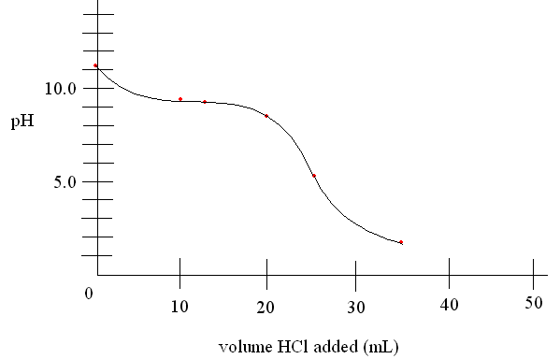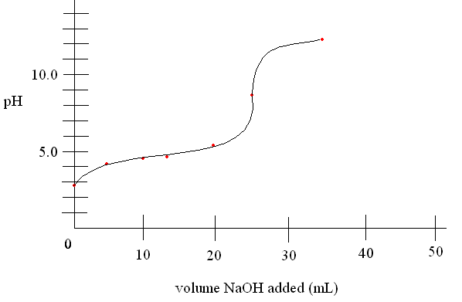

3. ________________________________________ 4. __________________________________________

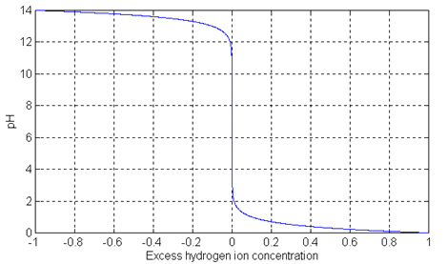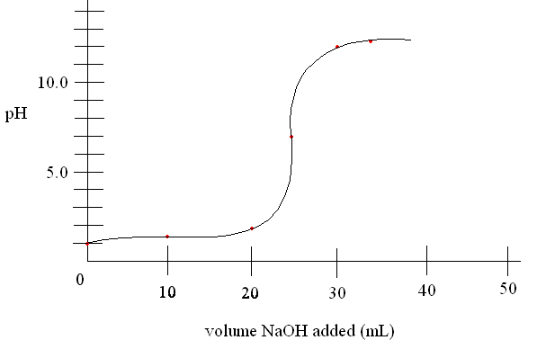

**Regents Review**

|  |  |  |  |
| --- | --- | --- | --- |
|  | **Key Idea Question** | **Justify your answer**  **with an explanation or calculation.** | **Confidence Level**  **None Moderate Fully**  http://www.mentisology.org/wp-content/uploads/2015/07/scale-1-10.jpg |
| 1 | Which of the following is not an electrolyte?   1. CH3COOH c. C2H5OH 2. NaOH d. LiCl |  | Pre-discussion:  Post discussion: |
| 2 | In the reaction, water acts as the  NH3 + H2O ↔ NH4+ + OH-   1. Acid because it donates H+ 2. Base because it donates H+ 3. Acid because it accepts H+ 4. Base because it accepts H+ |  | Pre-discussion:  Post discussion: |
| 3 | Which of the following represents a 100x increase in H3O+ concentration?   1. pH 3🡪 5 c. pH 6🡪2 2. pH 8🡪 11 d. pH 9🡪7 |  | Pre-discussion:  Post discussion: |
| 4 | Which metal will not react with acids?   1. Cu c. Li 2. Zn d. Mg |  | Pre-discussion:  Post discussion: |
| 5 | Which ion is represented by X?  H2O + HI 🡪 I- + X   1. Hydronium c. hydrogen 2. Hydroxide d. iodide |  | Pre-discussion:  Post discussion: |
| 6 | Complete the neutralization reaction:  __H2SO4 +__ LiOH 🡪 _______ + __HOH |  | Pre-discussion:  Post discussion: |
| 7 | Calculate the Molarity of 50.0mL HCl neutralized by 100.0mL of 2.0M NaOH. |  | Pre-discussion:  Post discussion: |
| 8 | Which is the best indicator for determining the difference between a strong acid with a pH of 2.0 and a weak acid with a pH of 5.0? |  | Pre-discussion:  Post discussion: |
| 9 | Explain what happens to the hydroxide and hydrogen ion concentration as lemon juice (citric acid) is added to iced tea (neutral). |  | Pre-discussion:  Post discussion: |
| 10 | Sketch a representation of how HCl is oriented around the water molecule as it dissolves and explain why HCl is classified as an electrolyte only in the aqueous phase. |  | Pre-discussion:  Post discussion: |

**Common Sense Chemistry Review**

**Pretty basic stuff.** ***🡨 Acid what you did there***

1. Identify the ingredients in the following common household chemicals as acids, bases, salts, or neither:
   1. Aspirin HOOCC6H4OOCCH3
   2. Glass cleaner NH4OH
   3. Ethanol C2H5OH
   4. Bleach ClO-
   5. Baking Soda NaHCO3
   6. Deodorant Al(OH)3
2. A farmer tests his soil with pH paper and finds the value to be 5.5, which could explain why his crops are dying.
   1. Is the soil acidic, basic, or neutral?
   2. Identify a substance that could be added to the soil that would make the soil more suitable for farming (more neutral).
   3. The farmer adds lime to the soil on the east side of his farm and re-tests the pH. The pH rises to 8.5, which further weakens his plants. Has the hydronium concentration increased or decreased, and by what factor has it changed?
   4. The farmer calls in a specialist to help with his dying plants. First the specialist quick tests the soil with a few indicators. Identify the color changes expected for each indicator on the east and west side of his farm: East West
      1. Methyl orange ____________________ _____________________
      2. Bromothymol blue ____________________ _____________________
      3. phenolphthalein ____________________ _____________________
      4. litmus ____________________ _____________________
      5. thymol blue ____________________ _____________________
      6. bromocrescol green ____________________ _____________________
   5. The specialist wants to determine the exact concentration of acid or base in the original soil in order to determine how to treat it effectively.
      1. What is the technique the specialist may use to determine the molarity of the soil?
      2. The specialist obtains a 150.0mL sample of soil and neutralizes the soil with 1.0M Ca(OH)2. The process requires 75.0mL of Ca(OH)2.
         1. How does the specialist know when to end the process when the soil was neutralized?
         2. Calculate the concentration of the acid or base present in the original soil.