Name: ______________________________________________ Titration Lab Post Questions

In another class, standardized potassium hydroxide solution, 0.250M KOH(aq), is used to determine the concentration of an unknown strong monoprotic acid. A volume of 10.00mL of the unknown acid is added to a flask, KOH was added dropwise, and phenolphthalein was used to mark the end point of the titration. Data set 1 below represents accurate student data. Calculate the Molarity of the unknown acid solution and complete the table below for data set 1.

 | Data Set 1 | Data Set 2 | Data Set 3
Volume of unknown acid | 10.00 mL | 10.00 mL | 10.00 mL
Initial volume of KOH | 0.00 mL | 0.00 mL | 0.00mL
Final volume of KOH | 32.55mL
Molarity of unknown acid

Additional students completed the experiment as well with errors outlined below. For each set of data, read the error below and estimate how the final volume of KOH will be affected. Then calculate the students’ Molarity of the unknown acid. Add all calculated answers to the data table above.
- Data Set 2: The student began the titration with an empty burette tip.
- Data Set 3: The student titrated until the resulting solution was dark pink.

For each data set, explain how the errors affected the calculated Molarity of the unknown acid.

Data Set 2: ________________________________________________________________________

________________________________________________________________________

Data Set 3: ________________________________________________________________________

________________________________________________________________________

A student wants to test if the same concentration and volume of vinegar will have the same results as the strong acid. Explain below how the student can set up the investigation. Include variables, controls, and a brief description of the procedure.

_______________________________________________________________________________

_______________________________________________________________________________

Predict the results of the student’s new experiment based on your knowledge of acids and bases.

_______________________________________________________________________________

_______________________________________________________________________________

Name: ______________________________________________ Titration Curve Lab Post Questions
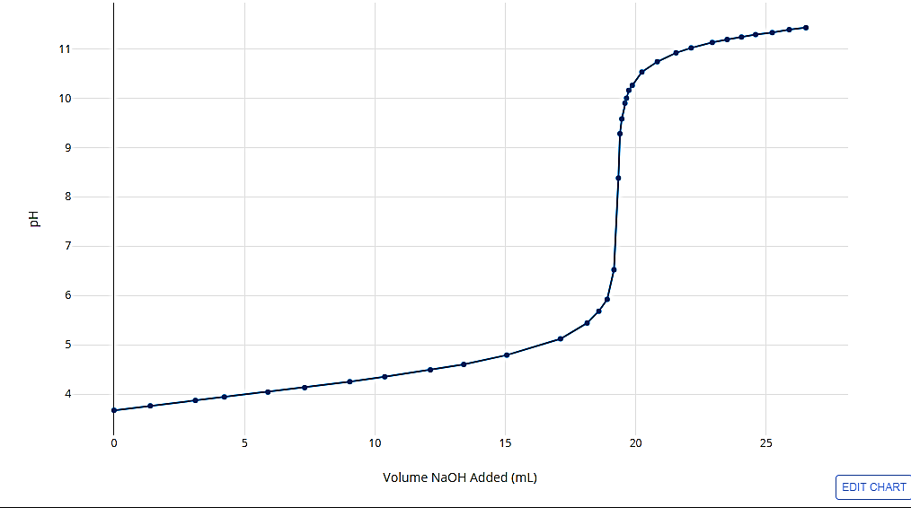
 | Data Set 1 | Data Set 2 | Data Set 3
Equivalence  Point pH |  |  | 7
Equivalence Point Volume (mL)
Half Equivalence Point pH
Half Equivalence Volume (mL)
Molar Mass of Unknown Acid (g/mol)
Ka (Dissociation Constant) of Unknown Acid
In another class, standardized potassium hydroxide solution, 0.250M KOH(aq), is used to titrate 1.50g an unknown weak solid acid. KOH was added dropwise to a solution of the unknown acid and a pH meter recorded data to create the curves below. The experiment 1 data was run successfully with very little error. Use the graph to determine the equivalence and half equivalence values and record the data in the table below.

Additional students completed the experiment as well with errors outlined below. For each set of data, read the error below and estimate how the equivalence and half equivalence points will be affected. Then calculate the students’ Molar Masses and Ka of the unknown acid. Add all calculated answers to the data table above.
- Data Set 2: After finding and recording the mass of unknown acid used, the student dropped some of the acid and never recovered it, continuing the lab as if it didn’t happen.
- Data Set 3: A student does the lab correctly but then selects the equivalence point to be at pH=7 because they believe every titration results in a neutral solution.

For data set 2, explain how the errors affected the calculated Molar Mass of the unknown acid.

________________________________________________________________________

________________________________________________________________________

For data set 3, explain how the errors affected the calculated Molar Mass of the unknown acid AND the calculated equilibrium constant for the unknown acid.
________________________________________________________________________

________________________________________________________________________

________________________________________________________________________

A student wants to find the Kb of an unknown base. Explain below how the student can set up the investigation. Include variables, controls, and a brief description of the procedure.

