Ionic Bond Formation

- Draw well diagrams to represent neutral Na and Cl atoms.

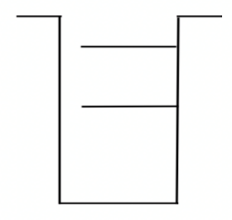
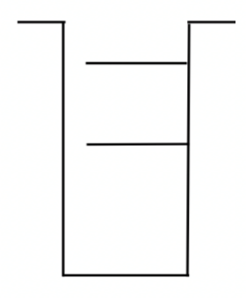

- Explain why the well of Cl is deeper and has more shelves than Na.

- Predict what would happen if energy were applied to both the Na and Cl atoms. Based on the strength of their attractive forces, which atom would it be easier to remove the electron from using that applied energy? Explain your answer using the well diagrams and ionization energy values.

- When the electron is removed from the atom predicted above, to which atom will it most like return to? Explain your answer using the well diagrams and ionization energy values.

- Draw new well diagrams to represent the Na and Cl after the energy is applied to remove the electron and the electron settles back into the system.
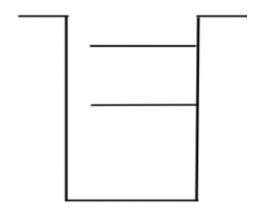

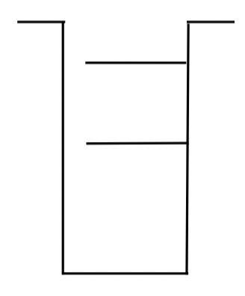
- Draw well diagrams to represent neutral Mg and Cl atoms.

- Predict what would happen if energy were applied to both the Mg and Cl atoms. Based on the strength of their attractive forces, which atom would it be easier to remove the electron from using that applied energy? Explain your answer using the well diagrams and ionization energy values.

- When the electron is removed from the atom predicted above, to which atom will it most like return to? Explain your answer using the well diagrams and ionization energy values.

- On your diagram above, show the migration of electrons as Mg react with Cl.
- Explain why more Cl atoms were needed to react with Mg than to react with Na. In other words, why does NaCl form and not NaCl₂ and why does MgCl₂ from and not MgCl?

- In summary, what happens subatomically when a metallic atom and a nonmetallic atom react to forma compound?

- What determines the ratio (chemical formula) in which the ions are used to form a compound?

Consider the well diagrams for two fluorine atoms. Diatomic fluorine, F₂(g) is a naturally occurring, highly toxic, pale yellow gas.
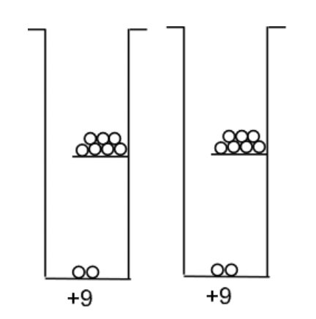

- Could the process you described for the formation of NaCl and MgCl₂ account for the formation of F₂? Explain your answer.

- Try to come up with a way to manipulate the well diagrams above to account for the bond that naturally occurs between two fluorine atoms.

- Does your model account for the fact that F₂ occurs naturally but F₃, F₄ and other combinations of F atoms do not occur naturally?

