Ionization Energy and Atomic Structure

Ionization Energy is the energy required to completely remove an electron from the atom.

The table attached lists the successive ionization energies of the first 20 elements. All ionization energies are measured in electron volts, a unit of energy roughly equal to 100kJ/mol.

- Describe a pattern you notice when you compare successive ionization energies of one element. Is there a trend when you read the values from the first ionization energy of any element to the last?

- What does this pattern or trend imply about the amount of energy needed to remove each electron from an atom one at a time? Does removing electrons require more or less energy as each is removed?

The ionization energies of selected period 2 elements are plotted below.

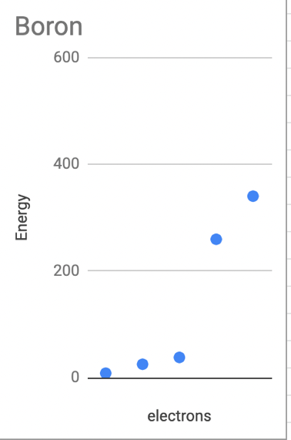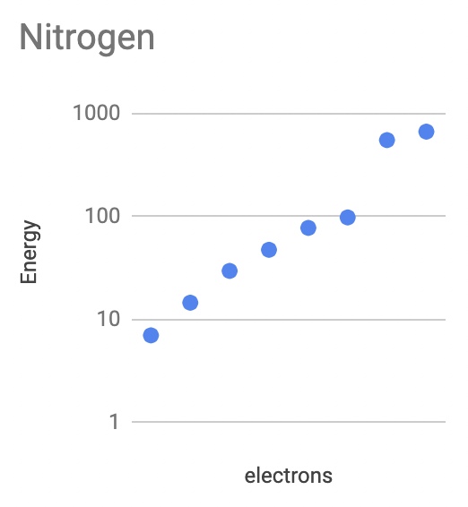
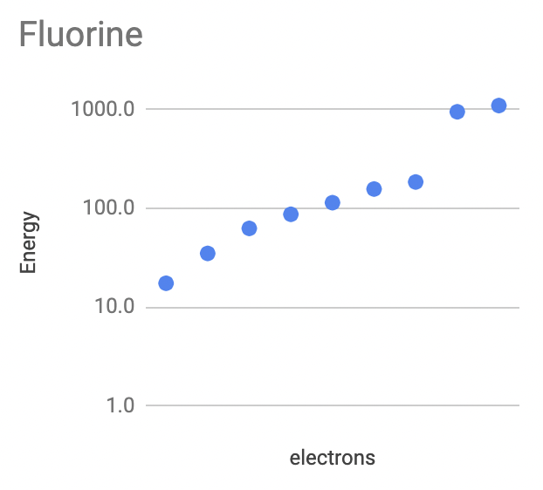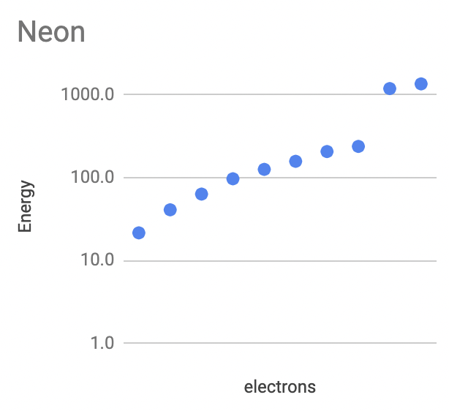

- Compare the graphs of the selected period 2 elements. Identify common features of the graphs.

- Group electrons in each graph based on how easy or difficult it is to remove them. Circle them on the plots and label them “easy to remove” and “difficult to remove.”
- Identify the maximum number of electrons that can fit in the group that is the most difficult to remove from the atom.

- Are all electrons in an atom created equal? What does this imply about Thomson and Rutherford’s models of the atom?

The ionization energies of selected period 3 elements are plotted below.
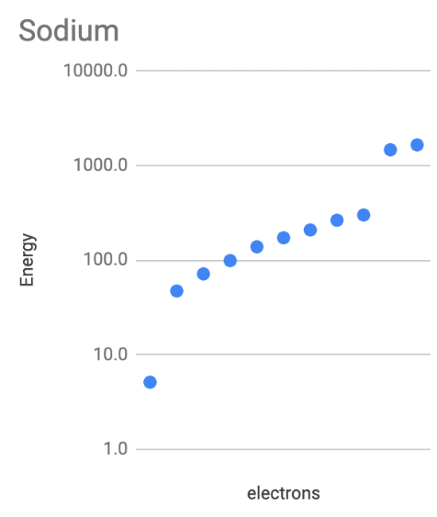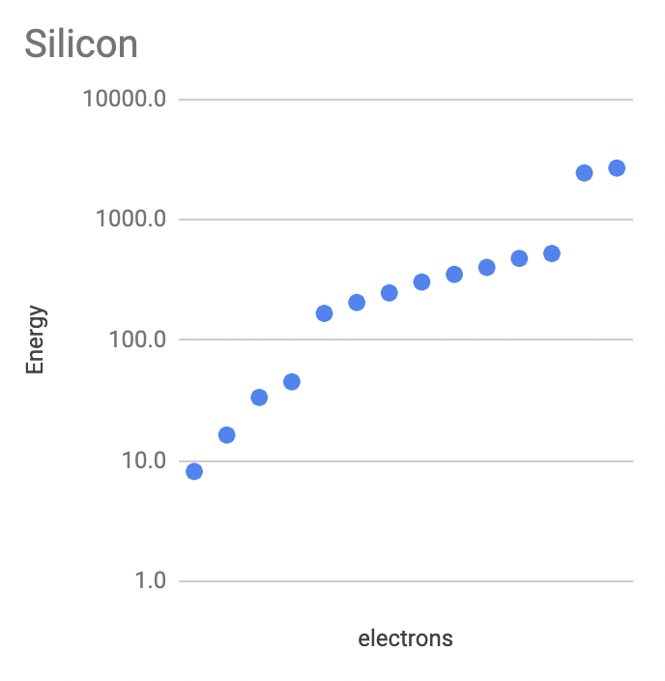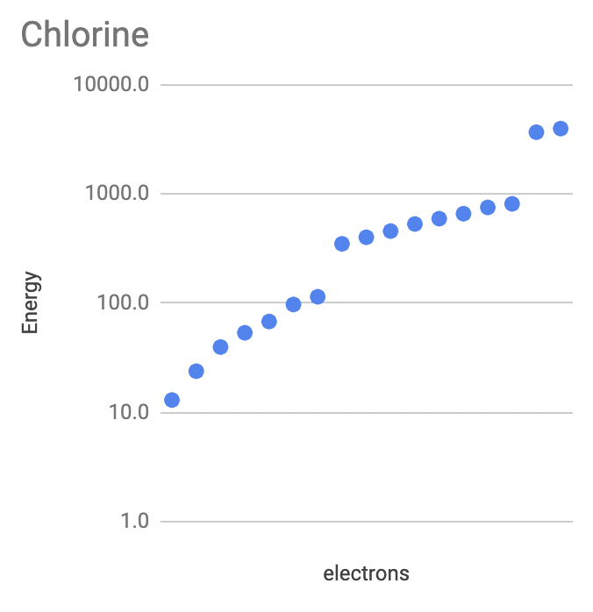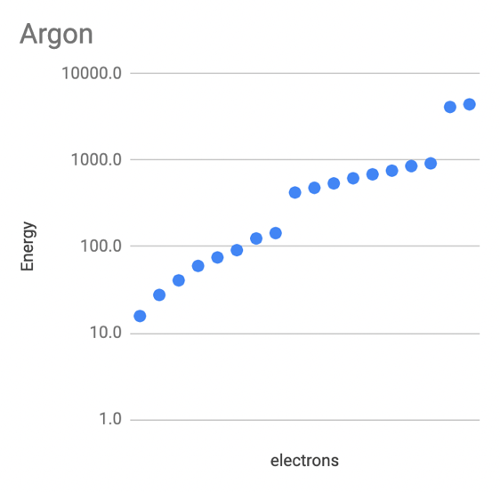

- Compare the graphs of the selected period 3 elements. Identify common features of the graphs.

- Group electrons in each graph based on how easy or difficult it is to remove them. Circle them on the plots and label them “easy to remove”, “hard to remove,” and “most difficult to remove.”
- Identify the maximum number of electrons that can fit in the group that is the most difficult to remove from the atom. Is this number of electrons similar or different from the period 2 elements?

The ionization energies of selected period 4 elements are plotted below.
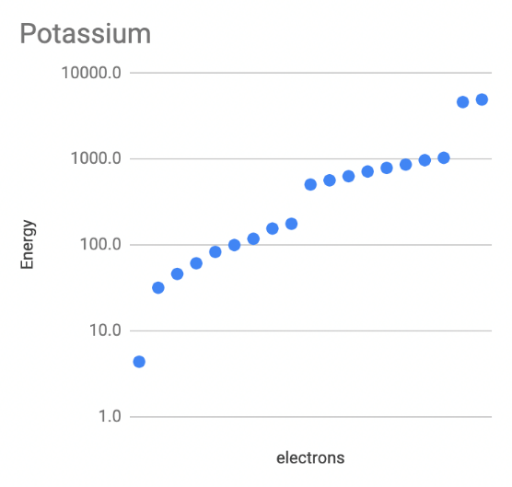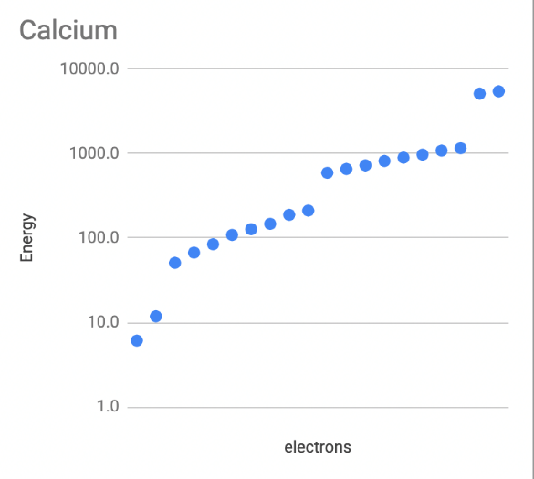

- Compare the graphs of the selected period 4 elements. How many groups of electrons would these plots need?

- Compare the plots of period 4 elements with those used above. Do the plots of period 4 elements support your claims above (How many electrons are the most difficult to remove/Does this evidence support Thomson’s model)?

- Notice your grouping of electrons for each set of plots. Summarize your findings below.

Period | Number of electron groupings | Number of electrons in the “most difficult to remove” grouping | Number of electrons in the “hard to remove” middle grouping
2
3
4

We will be using the analogy of a hole in the ground, or well, to think about why it takes an input of energy to remove electrons from the atom. According to the ionization energy data, it requires 13.6eV to remove the electron from hydrogen and 24.6eV to remove the first electron from helium.
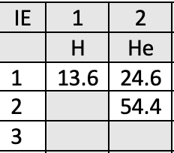

H +1 He +2
- Propose a reason it requires more energy to remove the first electron from helium than hydrogen.

- Propose a reason why it may be easier to remove the first person from the helium well and more difficult to remove the second person from that well.

- Propose a scientific reason it might be require less energy to remove the first electron from helium than the second.

Now consider the Lithium atom with 3 protons and 3 electrons. Notice that the first ionization energy is significantly lower than that of any energies of hydrogen and helium. Also notice that the 2nd ionization energy of Lithium is 14 times greater than the first while the 3rd ionization energy is only 1.6 times greater than the second. Two well diagrams are shown, one just like the H and He wells, and an alternate model that includes a ledge.
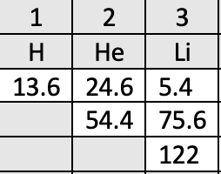

Li +3 Li+3

- Could a higher ledge inside the well help resolve this analogy with the ionization energy data? Explain your answer.

- Draw a well diagram for Beryllium based on the ionization energy data, next to the Lithium well diagram.

For simplicity, we will change the stick figures in our diagrams with circles to denote the electrons. Consider the following proposed well diagrams for oxygen and fluorine. Use ionization energy data to explain your answers to the following questions.

- Why do both diagrams have only 2 electrons at the bottom of the well?

- Why is the fluorine well deeper than the oxygen well?

- Using your reasoning from the previous question, should the ledges of Oxygen and fluorine be at the same depth? How would you amend the diagrams above to support your answer?

- Create your own well diagrams for fluorine, neon, and sodium using ionization energies. Consider the depth of the wells and ledges as well as the number of electrons in each location.

Reconsider the ionization energy graph of calcium and the corresponding well diagram:
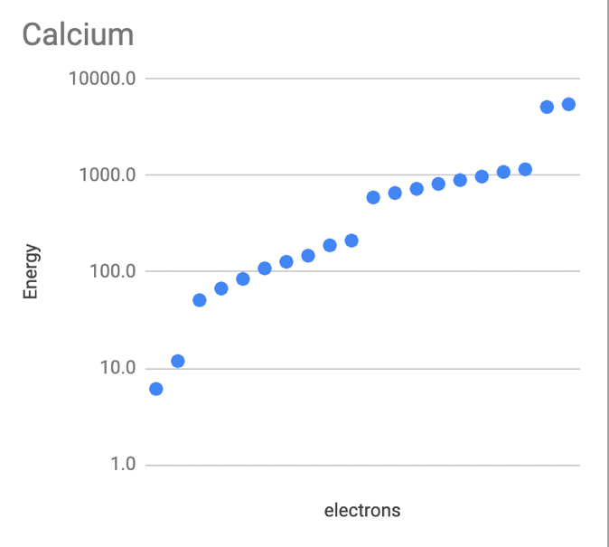

Ca +20
- Label both the graph and the well diagram with the following titles:
  - Most energy needed to remove
  - Least energy needed to remove

- Summarize the findings by using numbers or the words increases, decreases, most, or least.
  - The lowest level on a well diagram can contain a maximum of ______ electrons.
  - Each successive ledge on a well diagram can contain a maximum of ________ electrons.
  - As atomic number increases, the depth of the well ______________ and the depth of the ledges ____________________.
  - The electrons deepest in the well feel the proton pull the _________________ and therefore require the _________ energy to remove.
  - The electrons on the highest ledge feel the proton pull the _________________ and therefore require the _________ energy to remove.
Instead of well diagrams, which is an analogy for the actual model, Neils Bohr proposed a model of the atom that contained a nucleus containing protons and neutrons with electrons orbiting the nucleus in energy levels. The Bohr model of the calcium atom is shown below.

20 p⁺
20 n⁰

- How does the Bohr model compare to the well diagram of the calcium atom?

- Does the ionization energy data of calcium support the Bohr model of the calcium atom?

- Draw Bohr diagrams of the most common isotope of the following elements:

H | He | Li | Be
B | N | O | F

